Everybody’s Talkin’ (Harry Nilsson)

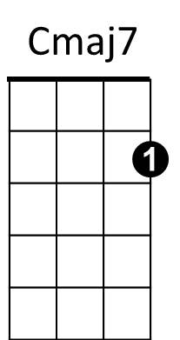
C Cmaj7
Everybody's talkin' at me
C C7
I don't hear a word they're sayin'
Dm G C Cmaj7 C Cmaj7
Only the echoes of my mind
C Cmaj7
People stop and starin'
C C7
C
Am
Dm
G
C7
I can't see their faces
Dm G C Cmaj7 C Cmaj7
Only the shadows of their eyes
Chorus:
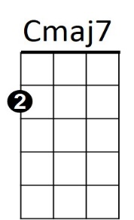
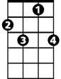Dm G
I'm goin' where the sun keeps shinin'
C C7
Through the pourin' rain
Dm G C G C7
Goin' where the weather suits my clothes...
Dm G
Banking off of the northeast winds
C C7
Sailin' on summer breeze
Dm G C Cmaj7 C Cmaj7
And skippin' over the ocean like a stone
C Cmaj7
G
Dm
BARITONE
Am
C
C7
Who-o-o-a whoa-whoa-whoa-whoa...
C C7
Whoa-whoa whoa-whoa whoa-whoa-whoa...
Dm G C Cmaj7 C Cmaj7
Who-o-o-o-o-o-o-o-o-a...
(Chorus)
C Cmaj7
Everybody's talkin' at me
C C7
I don't hear a word they're sayin'
Dm G C Cmaj7 C Cmaj7
Only the echoes of my mind
Dm G C Cmaj7 C Cmaj7
I won't let you leave my love behind
Dm G
No I won't let you leave...
C Cmaj7 C
Whoa.....whoa-a-h-h-h-h
Dm G C Cmaj7 C Cmaj7 (fade end on C)
I won't let you leave my love behind

