Everybody's Working for the Weekend (Paul Dean / Matthew Frenette / Mike Reno) Key A
Intro: Asus4 A

A F A
Everyone's watching to see what you will do
A F#m G
Everyone's looking at you... Oh
A F A
Everyone's wondering will you come out tonight?
A F#m G
Everyone's trying to get it right, get it right

Chorus:
C F
Everybody's working for the weekend
C F
Everybody wants a new romance
C F
Everybody's going off the dee p end
C F
Everybody needs a second chance, Whoa oh

TACET Asus4 A
You wanna piece of my heart?
Asus4 A
You better start from the start
Asus4 A
You wannna be in the show?
F
Come on baby, let's go!

F C / F C / F C A

A F A
Everyone's looking to see if it was you
A F#m G
Everyone wants you to come through
A F A
Everyone's hoping it'll all work out
A F#m G
Everyone's waiting, they're holding out!

(Chorus)

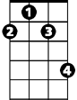
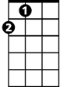

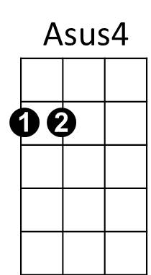
G
F#m
A
F

TACET Asus4 A
You wanna piece of my heart?
Asus4 A
You better start from the start
Asus4 A
You wannna be in the show?
F F Am F Am
Come on baby, let's go!
F C / F C / F C A
Hey!

Asus4 A
You wanna piece of my heart?
Asus4 A
You better start from the start
Asus4 A
You wannna be in the show?
Asus4 A
Come on baby, let's go
Asus4 A
You wanna piece of my heart?
Asus4 A
You better start from the start
Asus4 A
You wannna be in the show?
F
Come on baby, let's go!

F C / F C / F C A

BARITONE

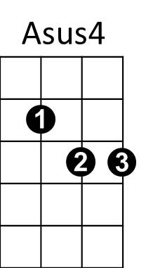


F
A
C
G

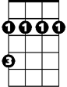
F#m

C

