FARE AWAY (Michael John Mckean / Annette O'toole / Jeffery Lynn Vanston)
(Performed by The Main Street Singers from 'A Mighty Wind’)

Intro: G / C Cmaj7 D G (Chorus 1 melody)

G C G
Sun breaks over the sprits'l yard,
C Cmaj7 A7 D
Jib sheet's haulin' to lee-ward hard.
G C G
Crosstree's hummin' a mornin' hymn,
C Cmaj7 D G D G
I'm the cabin boy; call me Jim. (His name's Jim).

G
Fare away, fare away, under main top sail,
C Cmaj7 D G
To the fur-be-low of the wily wha...le.

G C G
Captain's stalking the quarter-deck,
C Cmaj7 A7 D
Tells the tale of his first ship-wreck.
G C G
Castaway with a case of rum,
C Cmaj7 D G

Hoped that rescue would never come, (never come).
C

G
Fare away, fare away, under main top sail,
C Cmaj7 D G
To the fur-be-low of the wily whale.

C Cmaj7 D
D
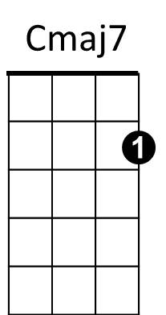
To the fur-be-low of the wi-ly, wi-ly...

(Verse melody)

G C G
First mate Adam's a hardened man,
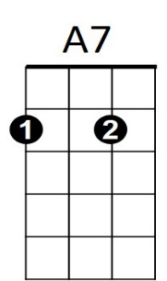
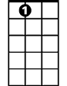
C Cmaj7 A7 D
A7
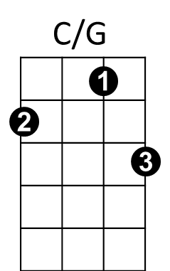
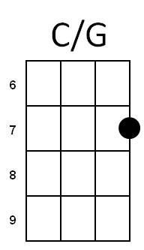
Says the captain's a charla-tan.
G C G
Don't know tackle from futtock plates,
C Cma7 D G
He'll sail us into the Pear...ly Gates.

G
Fare away, fare away, under main top sail,
C Cmaj7 D G
To the fur-be-low of the wily wha...le.

G C G
I been sailin' these seven seas,
C Cmaj7 A7 D
Since I's nigh high to a mermaid's knees.
G C G
Come next April I'm sixty-three,
C G C G
I can't ad-vance! (I like short pants!)
Am Em D G
Safe in the cabin on the open sea.
C Cmaj7 D G
Safe in the cabin on the open sea.

G
Fare away, fare away, under main top sail,
C Cmaj7 D G
To the fur-be-low of the wily wha...le.
C Cmaj7 C Cmaj7
To the fur-be-low of, to the fur-be-low of.
C Cmaj7 D C/G G

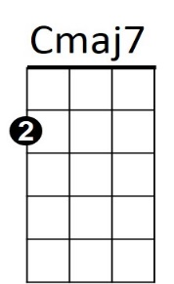

To the fur-be-low of the wily, wi-ly wha...le.
D
BARITONE
C
G
G

