Feelin’ Groovy – 59th St. Bridge Song
By Paul Simon – 1967
Arrangement by Lisa Kljaich – The Ukulele Fool – Tutorial Video

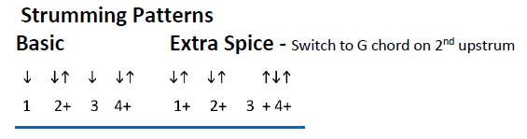
Starting vocal pitch – open E string
Each chord gets either half of a basic strum, or half of an extra spice strum.

Intro: C G Am7 G - 2x

C G Am7 G C G Am7 G
Slow down you move too fast, You gotta make the morning last
C G Am7 G C G Am7 G
Kickin' down the cobble stones, Looking for fun and feeling' groovy

Refrain
C G Am7 G
C G Am7 G
Babada Da da Da da feelin' groovy,
C G Am7 G
Da da Da da feelin' groovy

C G Am7 G C G Am7 G
Hello lamp post, whatcha knowing? I've come to watch your flowers growin'
C G Am7 G C G Am7 G
Ain't cha got no rhymes for me? Dootin doo doo feeling groovy. Refrain

C G Am7 G
I've got no deeds to do, no promises to keep
C G Am7 G
I'm dappled and drowsy and ready to sleep
C G Am7 G
Let the morning time drop all its petals on me
C G Am7 G
Life, I love you, all is groovy

C G Am7 G - Repeat 4 times

C G Am7 G G G ↓
Babada Da da Da da feelin' groovy - Repeat 3 times and fade

