Fish Song (Nitty Gritty Dirt Band) Key C

C Am F
Sat here by this stony brook until the grey day turned to dusk
C F G
When up swam a fish with a children's book thought that I was lost.
C Am F
He was on his way to the salmon hop, that's where they go to breed



C G F C
C
Am
F
Saw me sitting on this log and thought I'd like to read.

Refrain:
F C F C
The night was cloudy but the moon he found a hole



F C Am G G7
Dm
G7
G
Said that he felt bad for me ‘cause I had no place to go

TACET
The moon started talkin’ ~
Dm Am F C
Why aren't you at the harvest ball with some sweet young gal
Am F G G7
You just sit like a bump on the log and call that fish your pal.

C Am F
BARITONE

Well, I told him I was an orphan and lived here all alone
F
C
Am
C G F C
But many people have often tried to catch and take me home
TACET
They never caught me!

Instrumental Refrain


Dm
G7
G
C Am F
Thought that I was a-hiding, call this log my home
C G
But the fish and the moon and a sweet young gal
F C
All want me for their own.

(Refrain)

Dm Am F C
So I met that gal at the harvest ball, she took me to her room
Am F C
While I slept in children's dreams, the fish ran away with the moon.
F C
The fish ran away with the moon
F C
The fish ran away with the moon
F C
Na-na-na-na-hee (repeat to fade)

Fish Song (Nitty Gritty Dirt Band) Key G

G Em C
Sat here by this stony brook until the grey day turned to dusk
G C D
When up swam a fish with a children's book thought that I was lost.
G Em C
He was on his way to the salmon hop, that's where they go to breed
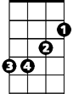
G D C G
Em
G
C
Saw me sitting on this log and thought I'd like to read.

Refrain:
C G C G
The night was cloudy but the moon he found a hole
C G Em D D7
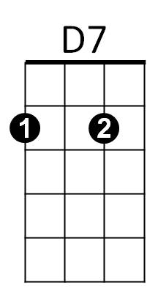

Said that he felt bad for me ‘cause I had no place to go
Am
D

TACET
The moon started talkin’ ~
Am Em C G
Why aren't you at the harvest ball with some sweet young gal
Em C D D7
You just sit like a bump on the log and call that fish your pal.

G Em C
Well, I told him I was an orphan and lived here all alone
BARITONE
G D C G
C
G
Em
But many people have often tried to catch and take me home
TACET
They never caught me!

Instrumental Refrain
Am
D7
G Em C
D
Thought that I was a-hiding, call this log my home
G D
But the fish and the moon and a sweet young gal
C G
All want me for their own.

(Refrain)
Am Em C G
So I met that gal at the harvest ball, she took me to her room
Em C G
While I slept in children's dreams, the fish ran away with the moon.
C G
The fish ran away with the moon
C G
The fish ran away with the moon
C G
Na-na-na-na-hee (repeat to fade)

