The Flintstones Theme (Hoyt Curtin / William Hanna / Joseph Barbera)
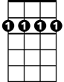
Bm7

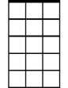
G Am7 G Bm7
G
Am7
Flintstones, ...meet the Flintstones,
G Am7 D7 G Am7 D7
They're the modern Stone Age fam - i - ly,
G Am7 G
From the ...town of Bedrock,
D7 G Am7 D7 G
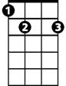
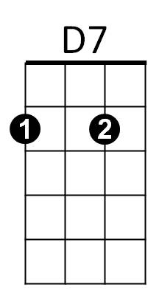
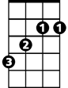
They're a page right out of his - tor - y!
E7
B

B E7
Let's ride ...with the family down the street,
A A7 Am7 D D7
Through the ...courte - sy of Fred's two feet!

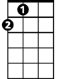
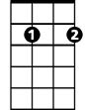

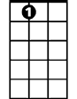
G Am7 G
A
Em7
D
A7
When you're ...with the Flintstones,
D7 G Am7 D7
Have a yabba -dabba -doo time,
G Am7 D7
A dabba - doo tim e,
G Am7 D7 G
We'll have a gay old time!

G Am7 G Bm7
Flintstones, ...meet the Flintstones,
G Am7 D7 G Am7 D7
They're the modern Stone Age fam - i - ly,
G Am7 G
From the ...town of Bedrock,
D7 G Am7 D7 G
They're a page right out of his - tor - y!

B E7
Someday, ...maybe Fred will win the fight,
BARITONE

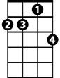

A A7 Am7 D D7
G
Am7
Bm7
D7
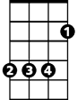
Then that ...cat will stay out for the night!
B

G Am7 G
When you're ...with the Flintstones,
D7 G Am7 D7
Have a yabba -dabba -doo time,
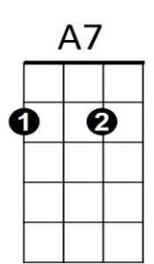
G Am7 D7
Em7
D
A
A dabba - doo time,
E7
G Am7 D7 G
We'll have a gay old time!

G Em7 Am7 D7 G

Am7 D7 G G
We'll have a gay old time--------------!

