Flower Of Scotland (Roy Williamson, mid 1960s)
Flower Of Scotland by The Corries (in F#) - Key of C

Intro (4 Measures) C  C G C | C  O flower of Scotland, when will we see your like again  F C G C  That fought and died for your wee bit hill and glen.  Chorus  G C F C  And stood a-gainst him, proud Edward's army.  F C F C | C  And sent him homeward, tae think a-gain.  C G C  The hills are bare now, and autumn leaves lie thick and still.  F C G C  O'er land that is lost now, which those so dearly held. Chorus  C G F C  Those days are passed now, and in the past they must re-main.  F C G C  But we can still rise now, and be the nation a-gain. Chorus  Repeat 1st Verse |  |  |  |  |  |  | 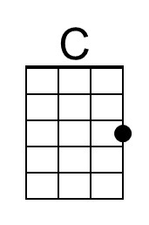
 |  |  |  |  |  |  | 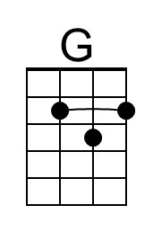
 |  |  |  |  |  |  | 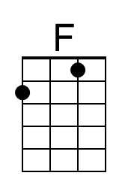
 |  |  |  | Bari | 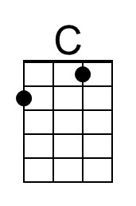 | 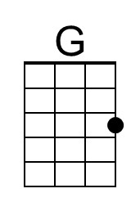 |  | 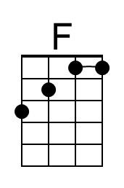

Flower Of Scotland (Roy Williamson, mid 1960s)
Flower Of Scotland by The Corries (in F#) - Key of F#

Intro (4 Measures) F#  F# C# F# | F#  O flower of Scotland, when will we see your like again  B F# C# F#  That fought and died for your wee bit hill and glen.  Chorus  C# F# B F#  And stood a-gainst him, proud Edward's army.  B F# B F# | F#  And sent him homeward, tae think a-gain.  F# C# F#  The hills are bare now, and autumn leaves lie thick and still.  B F# C# F#  O'er land that is lost now, which those so dearly held. Chorus  F# C# B F#  Those days are passed now, and in the past they must re-main.  B F# C# F#  But we can still rise now, and be the nation a-gain. Chorus  Repeat 1st Verse |  |  |  |  |  |  | 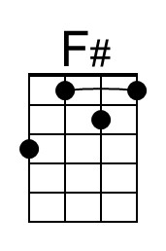
 |  |  |  |  |  |  | 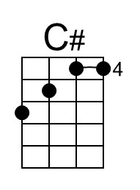
 |  |  |  |  |  |  | 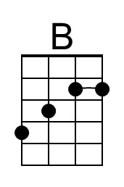
 |  |  |  | Bari | 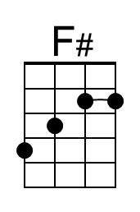 | 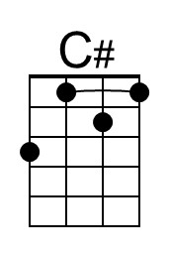 |  | 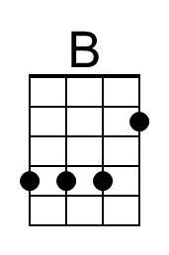

Flower Of Scotland (Roy Williamson, mid 1960s)
Flower Of Scotland by The Corries (in F#) - Key of G

Intro (4 Measures) G

G D G | G
O flower of Scotland, when will we see your like again
C G D G
That fought and died for your wee bit hill and glen.

Chorus
D G C G
And stood a-gainst him, proud Edward's army.
C G C G | G
And sent him homeward, tae think a-gain.

G D G
The hills are bare now, and autumn leaves lie thick and still.
C G D G
O'er land that is lost now, which those so dearly held. Chorus

G D C G
Those days are passed now, and in the past they must re-main.
C G D G
But we can still rise now, and be the nation a-gain. Chorus

Repeat 1st Verse

 |  |  |  |  |  |  | 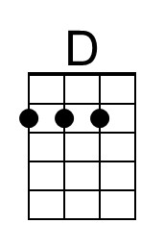
 |  |  |  | Bari |  | 