Fly Me To The Moon (In Other Words) (Bart Howard 1954)

Am/B Dm7 G7 Cmaj7 C7
Fly me to the moon, and let me play among the stars
F Dm6 E7 Am A7
Let me s ee what spring is like on Jupiter and Mars
Dm7 G7 Cmaj7 A7 Dm7 G7 Dm6 C E7
In other words, hold my hand In other words, darling, kiss me
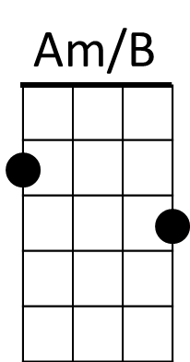
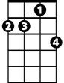
Dm7
Am/B Dm7 G7 Cmaj7 C7
Fill my heart with song and let me sing for ever more
F Dm6 E7 Am A7
You are all I long for, all I worship and adore
Dm7 G7 C9 A7 Dm7 G7 C E7

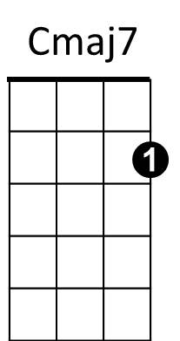
In other words, please be true, In other words, I love you
G7

Am/B Dm7 G7 Cmaj7 C7
Fill my heart with song and let me sing for ever more
F Dm6 E7 Am A7
You are all I long for, all I worship and adore


Dm7 G7 C9 A7 Dm7 D7
F
C7
In other words, please be true, In other words, In other words,
Dm7 G7/ C Dm7 Cmaj7 (slow arpeggio)
in other words, I love you.

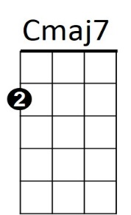
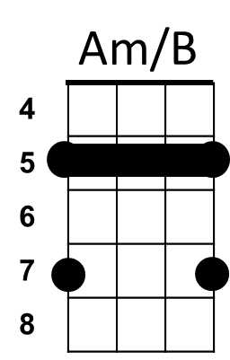
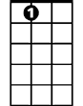
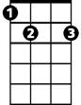
BARITONE
G7
A7
E7

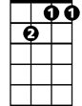
F
Dm7

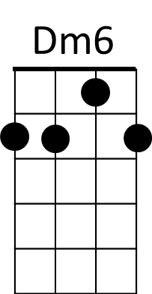
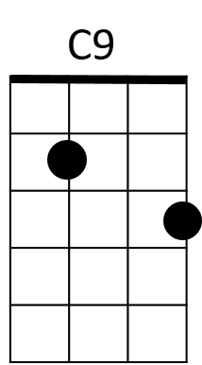
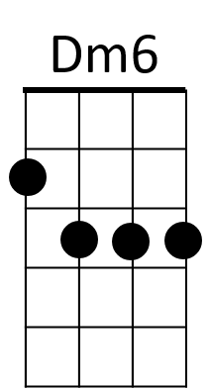
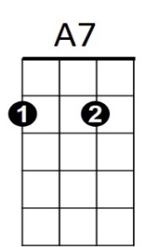
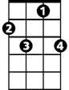
E7
C7
