Fools Rush In (Johnny Mercer and Ruby Bloom)
Key G

Intro: Chords for last 2 lines of second verse

Am D7 G
Fools rush in where angels fear to tread
Em Am D7
And so I come to you my love
G
My heart above my head
C Am D7 G
Though I see the danger there
D7 Am A7 D7
If there's a chance for me then I don't care

A m D7 G
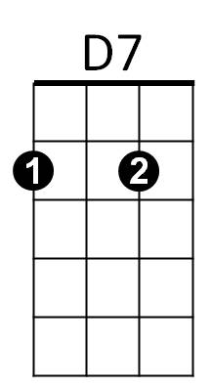
Fools rush in where wise men never go
Em Am D7
But wise men never fall in love
G G7
So how are they to kn-ow
Am G Em
When we met I felt my life begin
BARITONE
Am D7 Am G
So open up your heart and let this fool rush in
Am
G
Em

Repeat entire song

Em Am D7 Am G
Just open up your heart and let this fool rush in
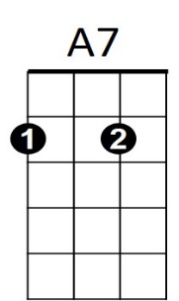

G7
D7G7
C
Fools Rush In (Johnny Mercer and Ruby Bloom)
Key C

Intro: Chords for last 2 lines of second verse

Dm G7 C
Fools rush in where angels fear to tread
Am Dm G7
C7
And so I come to you my love
C
My heart above my head
F Dm G7 C
Though I see the danger there
G7 Dm D7 G7
If there's a chance for me then I don't care

Dm G7 C
Fools rush in where wise men never go
Am Dm G7
But wise men never fall in love
C C7
So how are they to kn-ow
Dm C Am
When we met I felt my life begin
Dm G7 Dm C
BARITONE
So open up your heart and let this fool rush in
G7
Dm
C

Repeat entire song

Am Dm G7 Dm C
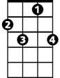Just open up your heart and let this fool rush in
D7
C7
Am
F

