For You a Lei

CHORDS USED IN THIS SONG  B7  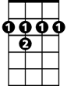  E7  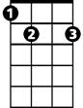  A  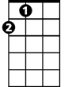  Bm  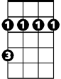  F#  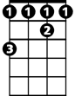  A7  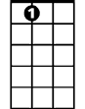  D    Dm   | "For You a Lei" by John Noble & Oscar Hyatt  Intro:  It is time to say goodbye, dear  Dry your tears and don't you cry  Take this flowered lei and while we're apart  Keep wearing it around your heart  Verse:  For you a [Bm] lei of [E7]flowers [A ]rare  For you a [Bm] lei to [E7]hold and [A ]wear  For you a [F#] lei to caress  When [B7] you go away  Throw your troubles away  And be [Bm] happy and [E7] gay  A lei of [Bm] love I [E7] give to [A] you  To think of [A7 ]me when you are [D]blue  Wherever you may [Dm] be  On the [A ]land or on the [F#] sea  For you a [Bm ]lei to re[E7] member [A] me  Try ending this song with the second position E7 and A E7
  E7  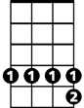 | A  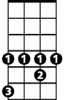

https://www.youtube.com/watch?v=FXAg8srJvB0
https://www.youtube.com/watch?v=FGr1_ljMVUM
https://www.youtube.com/watch?v=iiTigp1Ytxo
https://www.youtube.com/watch?v=KbMTWVUagWY

