From Me to You (John Lennon / Paul McCartney)

Intro: C G Am (2x)
Da da da da da dum dum da

C Am
If there's anything that you want,
C G7
If there's anything I can do,
F7 Am
Just call on me and I'll send it along
C G7 C
With love from me to you

C Am
I’ve got everything th at you want,
C G7



Like a heart that's oh, so true,
F
C7
Gm
F7 Am
Just call on me and I'll send it along
C G7 C
With love from me to you

Bridge:


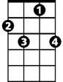
Gm C7
BARITONE
G7
Am
G
C7
I got arms that long to hold you
C
F
And keep you by my side.
D7

I got lips that long to kiss you
F
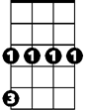
G Gaug G7
Gm
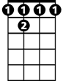
And keep you satisfied - oooo
F 7

(Repeat Verse 1)

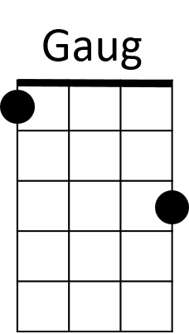
C Am

Da da da da da dum dum da (Call on me)
D7
C G7
Da da da da da dum dum da (To you)
F Am
Just call on me and I'll send it along
C G C
With love from me to you

(Bridge, Verse 1)

C7
To you, to you, to you,
C G Am
Da da da da da dum dum da


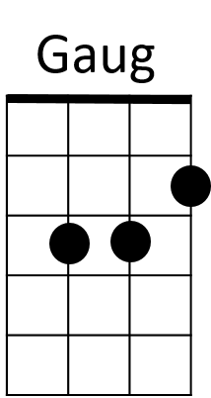
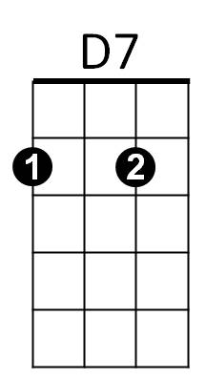
C
F7
G7
Am
G

