


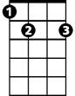
Georgia On My Mind
F
C
Am
E7

C E7 Am F Fm
Georgia, Georgia, the whole day through
C A7 Dm7 G7 E7
Just an old sweet song keeps Georgia on my mind
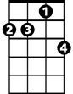
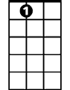
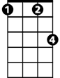
A7 D7 G G7
Dm7
A7
Fm

C E7 Am F Fm
Georgia, Georgia, A song of you
C A7 Dm7 G7 C
Comes as sweet and clear as moonlight through the pines

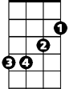
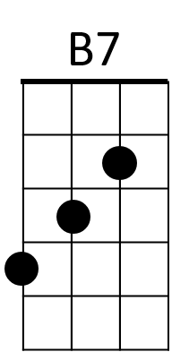


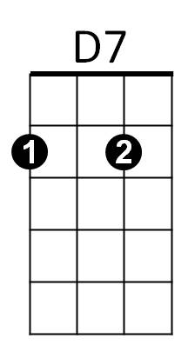
C F C E7
G7
Em
Dm
G

Chorus:
Am Dm Am F
Other arms reach out to me
Am Dm7 Am D7
Other eyes smile, tenderly
Am F C B7 (hold)
BARITONE
E7
C
Still in peaceful dreams I see
Am Em Dm7 G G7
The road leads back to you

C E7 Am F Fm

Georgia, Georgia, no pe ace I find
F
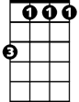
C A7 Dm7 G C
Am
Fm
Just an old sweet song keeps Georgia on my mind
C F C E7

(Chorus)
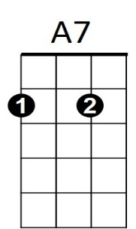
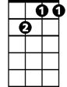

C E7 Am F Fm
Dm7
G7
Georgia, Georgia, no peace I find
C A7 Dm7 G7 E7
Just an old sweet song keeps Georgia on my mind
E7 A7 Am

Dm7
Em
D7
Dm
G
B7
Just and old sweet song keeps
G G7 C C F C
Georgia on my mind

