Getting to Know You (Richard Rogers / Oscar Hammerstein)
C Cmaj7
Getting to know you,
C Cmaj7 Dm G7 Dm G7
Getting to know all about you.
G7 Dm G7

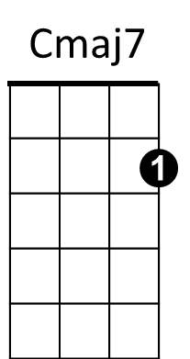



Getting to like you,
C
Dm
G7
G
Dm G7 C G
Getting to hope you like me.


C Cmaj7
C7

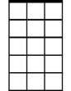
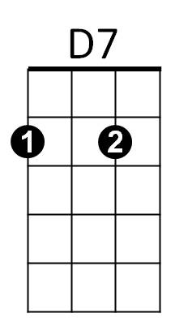
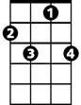
Getting to know you,
F
Am7
F7
C C7 F
Putting it my way, but nicely,
Am7 D7
You are precisely,
Dm G7
My cup of tea.

C Cmaj7
Getting to know you,
BARITONE
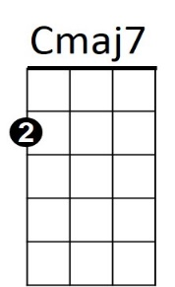

C Cmaj7 Dm G7 Dm G7
Dm
G7
C
Getting to feel free and ea - sy
G7 Dm G7
When I am with you,
Dm G7 C C7

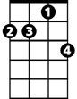
Getting to know what to say
G
C7
F
Am7
F F7
Haven't you no - ticed
Dm G7 Cmaj7 C7 F
Suddenly I'm bright and bree - zy?
Cmaj7 Dm G7
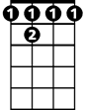
Because of all the beautiful and new
D7
F 7
C Am7 D7
Things I'm learning about you
Dm G7 C (play G7 to start from the top)
Day by day.

Getting to Know You (Richard Rogers / Oscar Hammerstein)
G Gmaj7
Getting to know you,
G Gmaj7 Am D7 Am D7
Getting to know all about you.
G


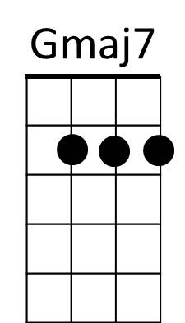
D7 Am D7
D
Am
Getting to like you,
BARITONE
Am D7 G D
Getting to hope you like me.

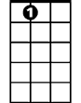
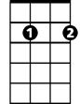
G Gmaj7
C7
G7
A7
Em7
C
Getting to know you,
G G7 C
Putting it my way, but nicely,
Em7 A7
You are precisely,
Am D7
My cup of tea.

G Gmaj7
Getting to know you,
G Gmaj7 Am D7 Am D7
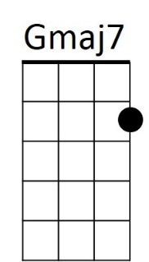
Getting to feel free and ea - sy
C
G7
Am
G
C7
Em7
D7
D7 Am D7
When I am with you,
Am D7 G G7
Getting to know what to say
C C7
D
Haven't you no - ticed
Am D7 Gmaj7 G7 C
Suddenly I'm bright and bree - zy?
Gmaj7 Am D7
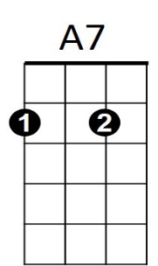
Because of all the beautiful and new
G Em7 A7
Things I'm learning about you
Am D7 G (play D7 to start from the top)
Day by day.

