Give A Little Bit - Supertramp
Intro: G7 C...G7 C...F G...F G...F C... (repeat twice)

C G7 C
Give a little bit,
F G F G F
Give a little bit of your love to me
C G7 C
I'll give a little bit,
F G F G F
I'll give a little bit of my love to you
Am Dsus4 D
There's so much that we need to share
F Am G C G
Send a smile and show you care
C G7 C
I'll give a little bit,
F G F G F
I'll give a little bit of my life for you
C G7 C
So give a little bit,
F G F G F
Give a little bit of your time to me
Am Dsus4 D
See the man with the lonely eyes
F Am G C G
Oh, Take his hand, you'll be surprised
E7 Am / E7 Am / E7 Bb / F Bb F G7 / C 6x / - C

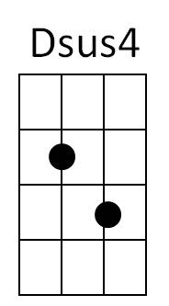
C G7 C
Am
Give a little bit,
F G F G F
Give a little bit of your love to me
C G7 C
Give a little bit,
F G F G F
I'll give a little bit of my life to you



Am Dsus4 D
BARITONE
F
C
G7
Now's the time that we need to share
Bb F Bb F G C G7
So find yourself, we're on our way back home
C G7 C
...oh going home
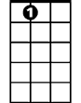
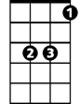
G7 C G7 C
E7
Bb
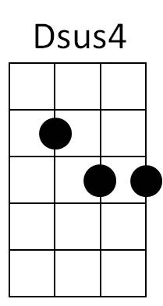

don't you need, don't you need to feel at home
D

G7 C F G F C
Am
.. oh yeah, we gotta sing

Bb F
Ooo You gotta get a feeling
C
Ooo You come along, too
Bb F
You talk about doin’ it
C
Come-a, come-a, come-a, come along
Bb F
Cha cha Doin’ it
C
Ooooooooo you come along too
Bb F
Yeah come along do it
C
Tag a looooooooooooooooo
Bb F
Come along too, While I’m all right
C Bb G7 C
Come a long way, oooooooh sing it tonight

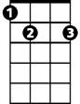


C F G F C
Bb
D
E7
G7
C
G
F

G

