Give Me Three Steps (Allen Collins and Ronnie Van Zant) (C)
Give Me Three Steps by Lynyrd Skynyrd

C  I was cutting the rug, down at place called The Jug  G  With a girl named Linda Lou  C  When in walked a man with a gun in his hand  D7 G  Looking for you know who  C  He said, "Hey there, fellow with the hair colored  F D7 yellow  Whatcha tryin' to prove?  C  'Cause that's my woman there and I'm a man who  G C cares  And this might be all for you"  - C G C G C  I said, "Excuse me"  C  I was scared and fearing for my life  G  I was shaking like a leaf on a tree  C  'Cause he was lean, mean, big and bad, Lord  D7 G  Pointin' that gun on me  C  "Oh, wait a minute, mister I didn't even kiss her  F D7  Don't want no trouble with you  C  And I know you don't owe me but I wish you'd let me  G C  Ask one favor from you" |  |  |  | Chorus  " Just gimme three steps,  gimme three steps, mister  G C  Gimme three steps toward the door?  C  Gimme three steps,  gimme three steps, mister  G C  And you'll never see me no more"  For, sure  C C  Well the crowd cleared away, and I be-gan to pray  G  And the water fell on the floor  C  And I'm telling you, son, well, it ain't no fun  D7 G  Staring straight down a forty-four  C  Well, he turned and screamed at Linda Lou  F D7  and that's the break I was looking for  C  Well, you could hear me screaming a mile away  G C  I was headed out toward the door. Chorus  Outro  - G C  Show me the back door.
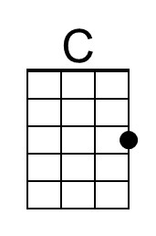 | 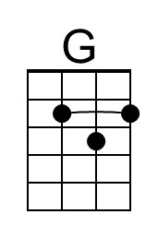 | 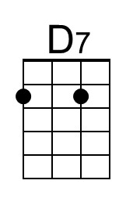 | 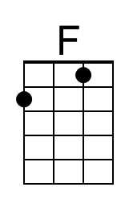 | 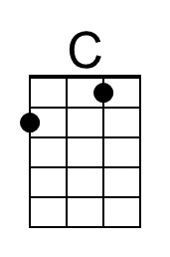 | 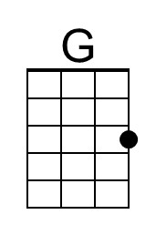 | 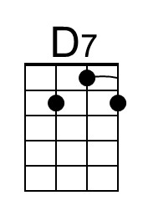 | 