God Bless America (Irving Berlin) Key C




Intro: Chords for last 2 lines
G
C
G7

C G
God Bless America


G7 C
F
C7
Land that I lo ve
C7 F C
Stand beside her, and guide her
G7 C
Thru the night wi th a light from above

G G7 C
From the mountains, to the prairies
G G7 C C7
To the oceans, white with foam
F G7 C
God bless America
F C G C
My home sweet home
F G7 C
God bless America
F C G C
My home sweet home -- REPEAT FROM TOP
BARITONE
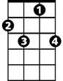

F G7 C
G7
G
C7
F
C
God bless America
F C G F C
My home sweet ho -me

God Bless America (Irving Berlin)

Intro: Chords for last 2 lines
F
C7
C
BARITONE
F C
God Bless America
C7 F
Land that I love
F7 Bb F
Bb
F7
Stand beside her, and guide her
C7 F
Thru the night with a light from above

C C7 F
From the mountains, to the prairies
C C7 F F7
To the oceans, white with foam
Bb C7 F
God bless America
Bb F C F
My home sweet home
Bb C7 F
God bless America
Bb F C F
My home sweet home -- REPEAT FROM TOP

Bb C7 F
God bless America
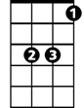
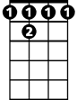
Bb F C Bb F
Bb
F 7
C7
C
F
My home sweet ho -me

God Bless America (Irving Berlin)

Intro: Chords for last 2 lines
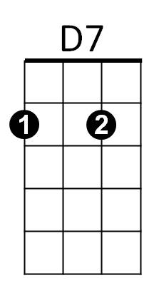

D
G
G D
BARITONE
God Bless America
D7 G
Land that I love
G7 C G
C
G7
Stand beside her, and guide her
D7 G
Thru the night with a light from above

D D7 G
From the mountains, to the prairies
D D7 G G7
To the oceans, white with foam
C D7 G
God bless America
C G D G
My home sweet home
C D7 G
God bless America
C G D G
My home sweet home -- REPEAT FROM TOP

C D7 G
God bless America
C G D C G
My home sweet ho -me
D7
D
G
C
G7

