
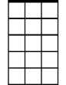
Golden Slumbers / Carry that Weight / The End (Lennon/McCartney)
Dm
Am7

Am7 Dm
Once there was a way____ to get back homeward
G7 C
Once, there was a way____to get back home
Em Am Dm




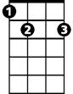


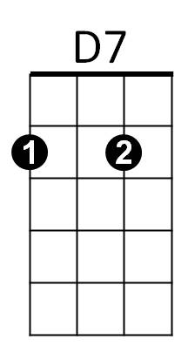
Sleep - pretty dar-ling, do not cry,
D
Am
G7
C
E7
F
G
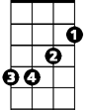
G7 C
Em
And I will sing a lullaby

C F C
Gold - en slumbers fill your eyes
C F C
Smiles awake you when you rise
Em Am Dm
Sleep - pretty dar-ling, do not cry,
G7 C
And I will sing a lullaby

(Repeat First Verse)

C G
Boy, you're gonna carry that weight
C
Carry that weight a long time.
G
Boy, you're gonna carry that weight
C G Am
Carry that weight a long time.


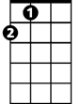
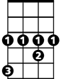
Am Dm / G7 F C / Am Dm E7 / Am G
Bb
A
Ab

Am Dm
I never give you my pil - low
G7 F C
I only send you my in - vitations
Am Dm E7
And in the middle of the cele - brations
Am G
I break down

C G
BARITONE
Boy, you're gonna carry that weight
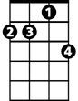

C
Am7
Dm
Carry that weight a long time.
G
Boy, you're gonna carry that weight
C
Carry that weight a long time.

C G D / C G D / D F / D G / C D7 C

C F D7 G C D7 C
Oh yeah, all right, are you gonna be in my dreams, tonight?

(drum solo)
G7
C F C F (12X)
Love you, love you, love you, love you
C //// //// //// ////
C Bb Ab D7 G
And in the end the love you take is equal to the love -
C A Bb C G
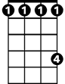
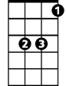
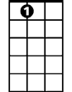
You make
D
C
Ab
A
Bb
D7
G
E7
F
Am
Em

