Good Mornin' (Arthur Freed / Nacio Herb Brown) Key C

C
Good Morning, Good Morning

We've talked the whole night through
F G C
Good Morning, Good Morning to you

C
Good Morning, Good Morning

It's great to stay up late
F G C
Good Morning, Good Morning to you

E7
When the band began to play
the stars were shining bright
G
Now the milkman's on his way
D7 G 7
and it's too late to say good night

C
So, Good Morning, Good Morning

Sun beams will soon smile through
F G C
Good Morning, Good Morning to you

And you , and you, and you!

C
Good Morning, Good Morning

We've gabbed the whole night through
F G C
Good Morning, Good Morning to you
NC
Nothing could be grander than to be in Louisiana

C
In the Morning, In the Morning

It's great to stay up late
F G C
Good Morning, Good Morning to you
N.C.
I'd be as yippe if it wasn't Mississippi

E7
When we left the movie show
the future wasn't bright
G
But came the dawn the show goes on
D7 G7
and I don't want to say good night

C
So say good morning, Good Morning

Rainbows are shining through
F G C
Good Morning, Good Morning to you

C


F
G

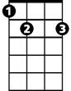

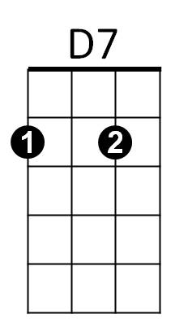
E7
G7

BARITONE

G
F
C


G7
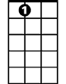
D7
E7

Good Mornin' (Arthur Freed / Nacio Herb Brown) Key G
G
Good Morning, Good Morning

We've talked the whole night through
C D G
Good Morning, Good Morning to you

G
Good Morning, Good Morning

It's great to stay up late
C D G
Good Morning, Good Morning to you

B7
When the band began to play
the stars were shining bright
D
Now the milkman's on his way
A7 D 7
and it's too late to say good night

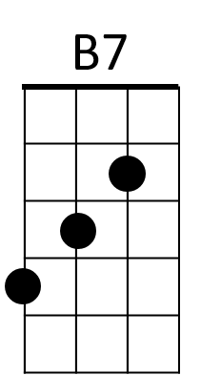
G
A7
So, Good Morning, Good Morning

Sun beams will soon smile through
C D G
Good Morning, Good Morning to you

And you , and you, and you!

G
Good Morning, Good Morning
BARITONE
D
C
G
We've gabbed the whole night through
C D G
Good Morning, Good Morning to you
NC
Nothing could be grander than to be in Louisiana
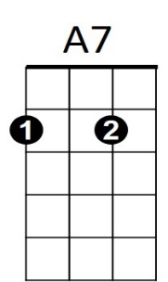
D7
B7
G
In the Morning, In the Morning

It's great to stay up late
C D G
Good Morning, Good Morning to you
N.C.
I'd be as yippe if it wasn't Mississippi

B7
When we left the movie show
the future wasn't bright
D
But came the dawn the show goes on
A7 D7
and I don't want to say good night

G
So say good morning, Good Morning

Rainbows are shining through
C D G
Good Morning, Good Morning to you


C
D
G

