Good Morning Starshine

G
Laa dada daa dada, daa dada daa dada,
Am D7 Am D7
Daa dada da da daa
Am D7
Dadada daa dada,
Am D7
Daa daa daa daa daa,
G
Dada, daha, daa

NC C D C
Good Morning starshine,
D C D C
The earth says "Hello",
D C D C D G Gsus4 D
You twinkle above us, we twinkle below
NC C D C
Good Morning starshine,
D C D C
you lead us a long,
B7 Em B7 C
my love and me as we sing,
A7 D7 G
our early morning singing song

Chorus:
G
Fliddy glup gloopy,
Am D7 Am D7
Nibby nabby noopy, la la la lo lo
Am D7
Sabba sibby, sabba,
Am D7 G G7
Nooby ab ba nab ba, li li lo lo
C B7 Em Am
Tooby ooby, walla, Nooby abba, naba,
G D7 G
Early morning singing song

BARITONE





D
C
D7
Am
G

NC C D C
Good Morning starshine,
D C D C
There´s love in your skies,
D C D C D G D

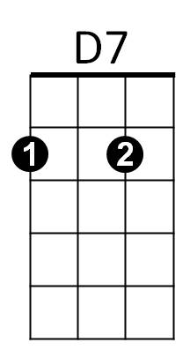
Reflecting the sunlight, in my lover´s eyes
Am
G
C
NC C D C
Good Morning starshine,
D C D C
So happy to be ,
B7 Em B7 C
My love and me as we sing,
A7 D7 G
Our early morning singing song

(Chorus)

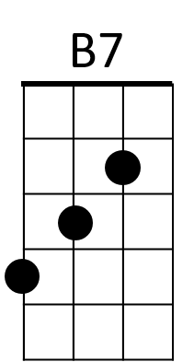

C D
D
Can you hear me?
G
Singing a song, humming a song,
Am D7 Am D7
Singing a song
Am D7 Am D 7
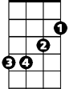
Loving a song, laughing a song,
Em
G G7
Sing the song
C B7 Em Am
Sing the song, song the sing,
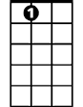
G Em Am D G
A7
song song song sing, sing sing sing song
G Em Am D7 G
Song song song sing, sing sing sing song

G Am D7 G
Sing sing song sing song, yea you can
G Am D7 G
G7
Sing sing song sing song, yea you can
G Am D7 G
Sing sing song sing song,
G Am D7 G

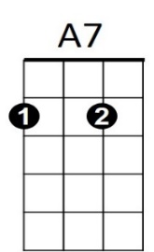
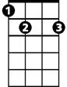
Sing sing song sing song, sing
G7
Em
B7

