Goodbye Yellow Brick Road (Elton John)
In tro: C Em Am F G7 C

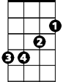

Em
C

Dm G
When are you gonna come down?
C F
When are you going to learn?
Bb G7
I should have strayed on the farm

C
Am
Should have listened to my old man
Dm G7
You know you can’t hold me forever
C F
I didn’t sign up w ith you
Bb G7
I’m not a present for your friends to open

C
F
This boy’s too young to be singing -

Ab Bb7 Eb Ab Fm G7
Bb
The B lu - es Ah ……. Ah

C E7
So goodbye yellow brick road

F C
G7
Where the dogs of society howl
A7 Dm
You can’t plant me in your penthouse
G7 C
I’m going back to my plow
Am Em
Back to the howling old owl in the woods
F Ab
Hunting the horny back toad
C Em Am
Oh I’ve finally decided my future lies
F G7
Beyond the yellow brick -
Ab Bb7 Eb Ab Fm G7 C
Ro - ad … Ah…..Ah ……Ah
BARITONE
Dm G
C
What do you think you’ll do then
C F
I bet they’ll shoot down your plane
Bb G7
It’ll take you a couple of vodka and tonics
C
To set you on your feet again

G7

Dm G7
Maybe you’ll get a replacement
C F
There’s plenty like me to be found
Bb G7
Mongrels who ain’t got a penny
C
Singing for tit - bits like you - On the-
Ab Bb7 Eb Ab Fm G7
Grou - nd ….Ah…..Ah

C E7
So goodbye yellow brick road
F C
Where the dogs of society howl
A7 Dm
You can’t plant me in your penthouse
G7 C
I’m going back to my plow
Am Em
Back to the howling old owl in the woods
F Ab
Hunting the horny back toad
C Em Am
Oh I’ve finally decided my future lies
F G7
Beyond the yellow brick -
Ab Bb7 Eb Ab Fm G7 C
Ro - ad … Ah…..Ah ……Ah
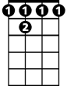
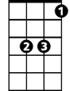
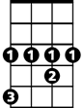
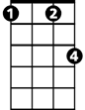
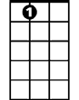

Bb7
Eb
Ab
Fm
A7
Dm

Em
Bb
Am
F


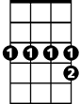
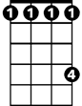
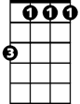
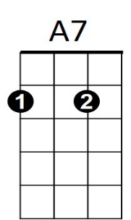
Dm
Bb7
Ab
Eb
Fm

Goodbye Yellow Brick Road (Elton John)
Dm
F
Am
Intro: F Am Dm Bb C7 F

Gm C
When are you gonna come down?
F Bb
When are you going to learn?
Eb C7
Bb
I should have strayed on the farm
F
Should have listened to my old man
Gm C7
You kn ow you can’t hold me forever
F Bb
C7
I didn’t sign u p with you
Eb C7
I’m not a present for your friends to open
F
This boy’s too young to be singing -
Db Eb7 Ab Db Bbm C7
Eb
The Blu - es Ah ……. Ah

F A7
A7
So goodbye yellow brick road
Bb F
Where the dogs of society howl
D7 Gm
You can’t plant me in your penthouse
C7 F
I’m going back to my plow
Dm Am
Back to the howling old owl in the woods
Bb Db
Hunting the horny back toad
F Am Dm
Oh I’ve finally decided my future lies
Bb C7
Beyond the yellow brick -
Db Eb7 Ab Db Bbm C7 F
BARITONE
Ro - ad … Ah…..Ah ……Ah
Am
F

Gm C
What do you think you’ll do then
F Bb
I bet they’ll shoot down your plane
Eb C7
It’ll take you a couple of vodka and tonics
Ab
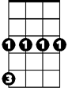
F
Gm
C
To set you on your feet again

Gm C7
Maybe you’ll get a replacement
F Bb
There’s plenty like me to be found
Eb C7
Mongrels who ain’t got a penny
F
Singing for tit - bits like you - On the-
Db Eb7 Ab Db Bbm C7
Grou - nd ….Ah…..Ah

F A7
So goodbye yellow brick road
Bb F
Where the dogs of society howl
D7 Gm
You can’t plant me in your penthouse
C7 F
I’m going back to my plow
Dm A
Back to the howling old owl in the woods
Bb Db
Hunting the horny back toad
F Am Dm
Oh I’ve finally decided my future lies
Bb C7
Beyond the yellow brick -
Db Eb7 Ab Db Bbm C7 F
Ro - ad … Ah…..Ah ……Ah
Bbm
Gm
Ab
Eb7
Db
C

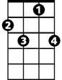
Eb
C7
Bb
Dm
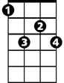
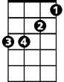
Eb7
Bbm

