Great Balls Of Fire (Otis Blackwell and Jack Hammer) (C)

C↓↓↓↓  You shake my nerves and you rattle my brain.  F7↓↓↓↓  Too much love drives a man insane.  G7↓↓↓↓ F7↓↓↓↓  You broke my will, but what a thrill.  C↓↓↓↓  Goodness gracious, great balls of fire!  C  I laughed at love 'cause I thought it was funny.  F7  You came along and moved me, honey.  G7 F7  I changed my mind; this looks fine.  C (H)  Goodness gracious, great balls of fire!  Reprise:  F7 C  Kiss me baby, mmmm! It feels good.  F7 G7 (H)  Hold me, baby. Well, I want to love you like a lover should.  ↓↓↓↓ You're fine, ↓↓↓↓ so kind, ↓↓↓↓  I'm a gonna tell the world that you're mine, mine, mine, mine.  C  I chew my nails and I then I twiddle my thumbs.  F7  I'm real nervous but it sure is fun!  G7 F7  Come on baby, you’re driving me crazy.  C (H)  Goodness gracious, great balls of fire!  (Repeat from Reprise)  Outro: ↓↓↓↓ |  |  |  |  |  |  | 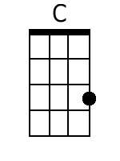
 |  |  |  |  |  |  | 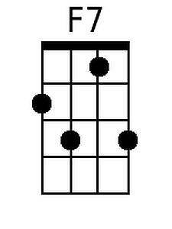
 |  |  |  |  |  |  | 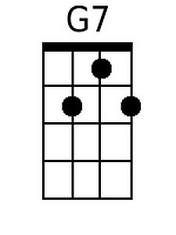
 |  |  |  |  |  |  | 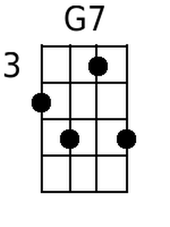
 |  |  |  |  |  |  | 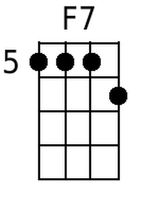
 |  |  |  |  |  |  | 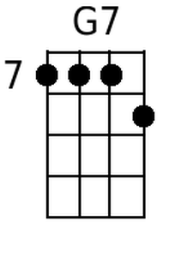
Bari
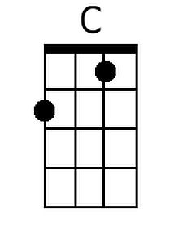 | 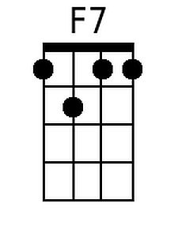 | 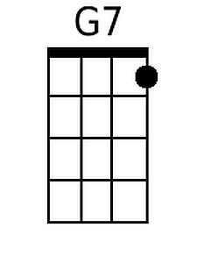 | 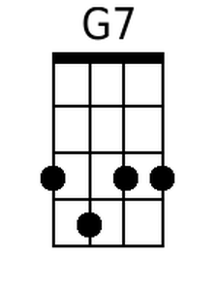 | 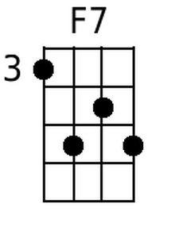 | 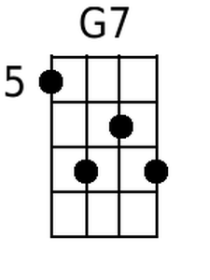

Great Balls Of Fire (Otis Blackwell and Jack Hammer) (G)

G↓↓↓↓  You shake my nerves and you rattle my brain.  C7↓↓↓↓  Too much love drives a man insane.  D7↓↓↓↓ C7↓↓↓↓  You broke my will, but what a thrill.  G↓↓↓↓  Goodness gracious, great balls of fire!  G  I laughed at love 'cause I thought it was funny.  C7  You came along and moved me, honey.  D7 C7  I changed my mind; this looks fine.  G (H)  Goodness gracious, great balls of fire!  Reprise:  C7 G  Kiss me baby, mmmm! It feels good.  C7 D7 (H)  __ Hold me, baby. Well, I want to love you like a lover should.  ↓↓↓↓ You're fine, ↓↓↓↓ so kind, ↓↓↓↓  I'm a gonna tell the world that you're mine, mine, mine, mine.  G  I chew my nails and I then I twiddle my thumbs.  C7  I'm real nervous but it sure is fun!  D7 C7  Come on baby, you’re driving me crazy.  G (H)  Goodness gracious, great balls of fire!  (Repeat from Reprise)  Outro: ↓↓↓↓ |  |  |  |  |  |  | 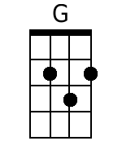
 |  |  |  |  |  |  | 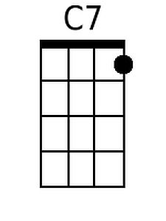
 |  |  |  |  |  |  | 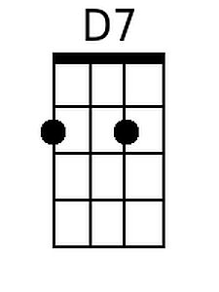
Bari
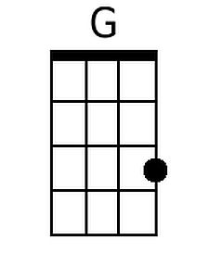 | 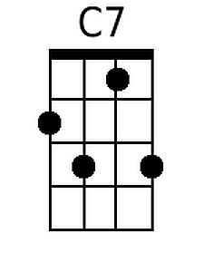 | 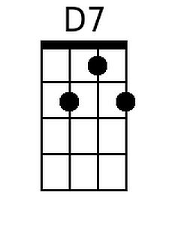 | 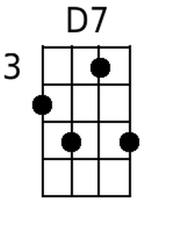 | 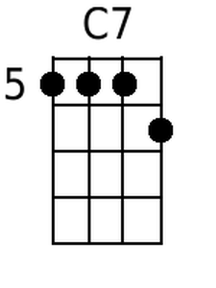 | 