
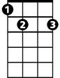
The Green Leaves of Summer (Dimitri Tiomkin / Paul Francis Webster)
Am
E7
Intro: Am E7 Am E7

Am E7
A time to be reaping
Am G
A time to be sowing

C Dm
G
The green leaves of summer
B7 E7
Are calling me h ome

A7 Dm

'Twas so good to be young then
C
G7 C
In the season of plenty
Am B7
Whe n the catfish were jumping
Am E7 Am


As high as the sky
G7
Dm

Am E7
A time just for planting
Am G
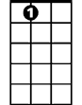
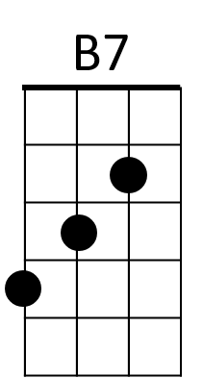
A time just for ploughing
A7
C Dm
A time to be cou rting
B7 E7
A girl of your own

A7 Dm
'Twas so good to be young then
G7 C
To be close to the earth
Am B7
And to stand by your wife
Am E7 Am
At the mo-ment of birth

Am E7
A time to be reaping
Am G
A time to be sowing
C Dm
A time just for living
B7 E7
A place for to die

Ending (2x)
A7 Dm
'Twas so good to be young then
G7 C
To be close to the earth
Am B7
Now the green leaves of summer
Am E7 Am
Are call - ing me home


BARITONE
E7
Am
C
G



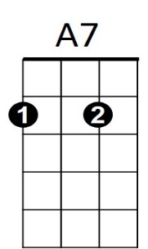
Dm
B7
G7

The Green Leaves of Summer (Dimitri Tiomkin / Paul Francis Webster)
C7
Gm
F
C
Dm
A7
E7
Intro: Dm A7 Dm A7

Dm A7
A time to be reaping
Dm C
A time to be sowing
F Gm
The green leaves of summer
E7 A7
Are calling me home

D7 Gm
'Twas so g ood to be young then
C7 F
In the season of plenty
Dm E7
When the catfish were jumping
Dm A7 Dm
As high as the sky

Dm A7
A time just for planting
Dm C
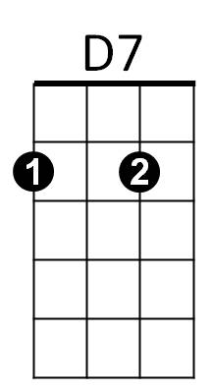
A time just for ploughing
F Gm
A time to be courting
E7 A7
A girl of your own

D7 Gm
'Twas so good to be young then
C7 F
To be close to the earth
Dm E7
And to stand by your wife
Dm A7 Dm
At the mo-ment of birth

Dm A7
A time to be reaping
Dm C
A time to be sowing
F Gm
A time just for living
E7 A7
A place for to die

Ending (2x)

D7 Gm
'Twas so good to be young then
C7 F
To be close to the earth
Dm E7
Now the green leaves of summer
Dm A7 Dm
Are call - ing me home

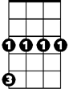

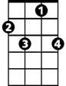
Gm
E7
D7
F
Dm
C
BARITONE
C7

