Green Tambourine (Paul Leka / Shelly Pinz) Key C
C G F (2x)

C G C G F



Drop your silver in my tambourine
F
G
C
C G C
Help a poor man fill his pretty dream
Fm C
Give me pennies I'll take anything
Eb Bbm
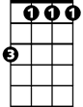
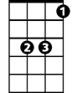
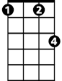
Now listen while I play,
Bbm
Eb
Fm
Fm C
My green tambourine

C G F (2x)

C G C G F
Watch the jingle jangle start to chime
C G C G F
Reflections of the music that is mine
Fm C
When you drop a coin you'll hear it sing
Eb Bbm
Now listen while I play,
Fm C
My green tambourine
BARITONE

C G F (2x)
F
G
C

C G C G F
Drop a dime before I walk away
C G C G F
Any song you want I'll gladly play
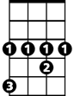
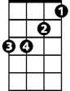
Fm C
Fm
Eb
Bbm
Money feeds my music machine
Eb Bbm
Now listen while I play,
Fm C
My green tambourine

C G F / C G F C

Eb Bbm (hold and let ring)
Now listen while I play. . .
Green Tambourine (Paul Leka / Shelly Pinz) Key G
G D C (2x)

D
G
C
BARITONE
G D G D C
Drop your silver in my tambourine
G D G
Help a poor man fill his pretty dream
Cm G
Give me pennies I'll take anything
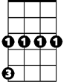
Bb Fm
Cm
Bb
Fm
Now listen while I play,
Cm G
My green tambourine

G D C (2x)

G D G D C
Watch the jingle jangle start to chime
G D G D C
Reflections of the music that is mine
Cm G
When you drop a coin you'll hear it sing
Bb Fm
Now listen while I play,
Cm G
My green tambourine
D
G
C

G D C (2x)

G D G D C
Drop a dime before I walk away
G D G D C
Bb
Any song you want I'll gladly play
Cm
Fm
Cm G
Money feeds my music machine
Bb Fm
Now listen while I play,
Cm G
My green tambourine

G D C / G D C G

Bb Fm (hold and let ring)
Now listen while I play. . .

