Greenback Dollar (Hoyt Axton & Ken Ramsey, 1962) Key: Am
Am C
Some people say I'm a no-count,
F Am





Others say I'm no good,
Am
C
G
G7
F
C F C F
But I'm just a natural-born travelin' man,
G Am
Doin' what I think I should, oh yeah,
G Am Am G Am G
Doin' what I think I should.

Chorus:
C F C F
And I don't give a damn about a greenback dollar,
C F C F
Spend it fast as I can,
C F C F
For a wailin' song, and a good gui-tar,
G7 Am
The only things that I under-stand, poor boy,
G7 Am Am G Am G
The only things that I under-stand.

Am C F Am
When I was a little baby, my mama said, "Hey son,
C F C F
Travel where you will, and grow to be a man,
BARITONE



G Am
Am
C
F
G7
G
And sing what must be sung, poor boy,
G Am Am G Am G
Sing what must be sung." Chorus

Am C
Now that I'm a grown man, I've traveled here and there,
C F C F
I've learned that a bottle of brandy and a song,
G Am
The only ones who ever care, poor boy,
G Am Am G Am G
The only ones who ever care. Chorus

Repeat first verse and chorus.

Outro:
G Am
The only things that I understand, poor boy,
G Am
The only things that I understand.

Greenback Dollar (Hoyt Axton & Ken Ramsey, 1962) Key: Em
Em G
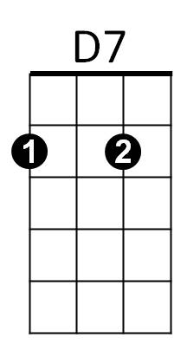
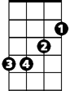
Some people say I'm a no-count,
Em
G
C Em
Others say I'm no good,
G C G C
But I'm just a natural-born travelin' man,
D Em
Doin' what I think I should, oh yeah,

D Em Em D Em D
C
D
Doin' what I think I should.

Chorus:
G C G C
And I don't give a damn about a greenback dollar,
G C G C
Spend it fast as I can,
G C G C
For a wailin' song, and a good gui-tar,
D7 Em
The only things that I under-stand, poor boy,
D7 Em Em D Em D
The only things that I under-stand.

Em G C Em
When I was a little baby, my mama said, "Hey son,
G C G C
Travel where you will, and grow to be a man,
D Em
BARITONE
Em
G
D
C
And sing what must be sung, poor boy,
D Em Em D Em D
Sing what must be sung." Chorus

Em G C Em
Now that I'm a grown man, I've traveled here and there,
G C G C
I've learned that a bottle of brandy and a song,
D7
D Em
The only ones who ever care, poor boy,
D Em Em D Em D
The only ones who ever care. Chorus

Repeat first verse and chorus.

Outro:
D Em
The only things that I understand, poor boy,
D Em Em D Em D Em D Em
The only things that I understand.

