Greenfields (Terry Gilkyson, Rich Dehr, and Frank Miller, 1956)
4/4 Time - Key: A Minor - "Moderately, with a beat"
Intro The last line of the verse.
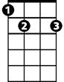Am Dm Am E7
Am
Dm
E7
Once there were green fields kissed by the sun
Am Dm Am E7
Once there were valleys where rivers used to run
F G7 Em7 A7
Once there were blue skies with white clouds high a-bove
Dm G7 Am E7
Once they were part of an everlasting love
Am Dm Am E7 Am Em Am E7
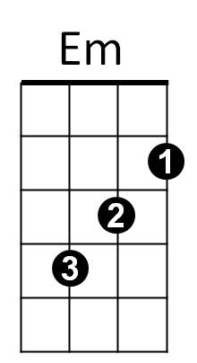
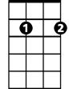We were the lovers who strolled through green fields
G7
Em7
F

Am Dm Am E7
Green fields are gone now, parched by the sun
Am Dm Am E7
Gone from the valleys where rivers used to run
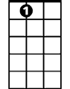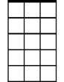F G7 Em7 A7
A7
C
Am7
Gone with the cold wind that swept into my heart
Dm G7 Am E7
Gone with the lovers who let their dreams de-part
Am Dm Am E7 Am Em Am E7
Where are the green fields that we used to roam

F G7 Dm G7 C Am7
I'll never know what made you run a-way
BARITONE
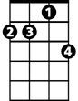Dm G7 Dm G7 C E7
Dm
Am
Em7
F
G7
Am7
E7
How can I keep searching when dark clouds hide the day
Am F Dm
I only know there's nothing here for me
Am Dm E7
Nothing in this wide world, left for me to see

Am Dm Am E7
Em
But I'll keep on waiting 'til you re-turn
Am Dm Am E7
I'll keep on waiting un-til the day you learn
F G7 Em7 A7
You can't be happy while your heart's on the roam
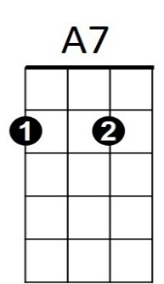
Dm G7 Am E7
C
You can't be happy un-til you bring it home
Am Dm Am E7 Am Em Am
Home to the green fields and me - once a-gain

Greenfields (Terry Gilkyson, Rich Dehr, and Frank Miller, 1956)
4/4 Time - Key: E Minor - "Moderately, with a beat"
Intro The last line of the verse.
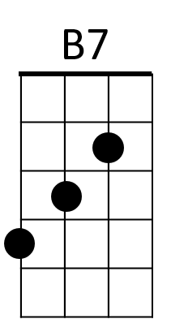
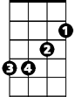 Em Am Em B7
Am
Em
Once there were green fields kissed by the sun
Em Am Em B7
Once there were valleys where rivers used to run
C D7 Bm7 E7
Once there were blue skies with white clouds high above
Am D7 Em B7
Once they were part of an everlasting love
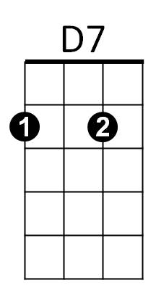
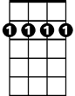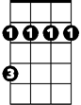Em Am Em B7 Em Bm Em B7
Bm7
C
Bm
We were the lovers who strolled through green fields

Em Am Em B7
Green fields are gone now, parched by the sun
Em Am Em B7
Gone from the valleys where rivers used to run
C D7 Bm7 E7
G
Em7
E7
Gone with the cold wind that swept into my heart
Am D7 Em B7
Gone with the lovers who let their dreams de-part
Em Am Em B7 Em Bm Em B7
Where are the green fields that we used to roam

Bridge
C D7 Am D7 G Em7
BARITONE
I'll never know what made you run a-way
Em
Am D7 Am D7 G B7
B7
Am
How can I keep searching when dark clouds hide the day
Em C Am
I only know there's nothing here for me
Em Am Am B7
Nothing in this wide world, left for me to see
C
D7
Bm7
E7
Em Am Em B7
But I'll keep on waiting 'til you re-turn
Em Am Em B7
I'll keep on waiting un-til the day you learn
C D7 Bm7 E7
You can't be happy while your heart's on the roam
Bm
Em7
G
Am D7 Em B7
You can't be happy un-til you bring it home
Em Am Em B7 Em Bm Em
Home to the green fields and me once a-gain

