

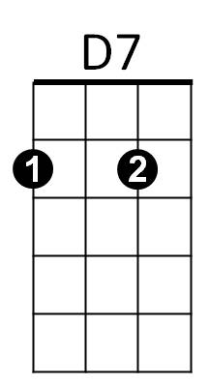
Hanalei Moon (Bob Nelson) Key C
C
G7
VAMP: D7 G7 C
C A7 D7
When you see Hana lei by moonlight
G7 C G7


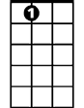
You will be in Heaven by the sea
D
F
A7
C A7 D7
Every breeze, every wave will whisper
G7 C G7
You are mine don't ever go a-way

C A7 D7

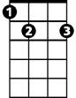
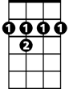
Hanalei, Hanalei moon
G
E7
B7
G7 F C G7
Is lighting beloved Kauaʻi
C A7 D7
Hanalei, Hanalei moon
G7 C A7
Aloha nō wau iā ʻoe

D B7 E7
BARITONE

When you see Hanalei by moonlight
C
D7
G7
A7 D A7
You will be in Heaven by the sea
D B7 E7
Every breeze, every wave will whisper

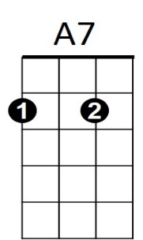
A7 D A7
D
F
You are mine don't ever go a-way

D B7 E7
Hanalei, Hanalei moon
A7 G D A7
Is lighting beloved Kauaʻi
B7
G
E7
D B7 E7
Hanalei, Hanalei moon
A7 D
Aloha nō wau iā ʻoe
A7 D VAMP: E7 A7 D
Aloha nō wau iā ʻoe

Hanalei Moon (Bob Nelson) Key F
F
C7
G7
VAMP: G7 C7 F
F D7 G7
When you see Hana lei by moonlight
C7 F C7
You will be in Heaven by the sea
Bb
F D7 G7
C
Every breeze, every wave will whisper
C7 F C7
You are mine don't ever go a-way

F D7 G7
Hanalei, Hanalei moon
A7
E7
G
C7 Bb F C7
Is lighting beloved Kauaʻi
F D7 G7
Hanalei, Hanalei moon
C7 F D7
Aloha nō wau iā ʻoe

G E7 A7
BARITONE
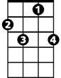
When you see Hanalei by moonlight
C7
G7
F
D7 G D7
You will be in Heaven by the sea
G E7 A7
Every breeze, every wave will whisper
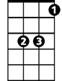
D7 G D7
Bb
C
D7
You are mine don't ever go a-way

G E7 A7
Hanalei, Hanalei moon
D7 C G D7
Is lighting beloved Kauaʻi
G
E7
G E7 A7
Hanalei, Hanalei moon
D7 G
Aloha nō wau iā ʻoe
D7 G VAMP: A7 D7 G
Aloha nō wau iā ʻoe

Hanalei Moon (Bob Nelson) Key G
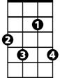
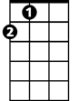
VAMP: A7 D7 G
D
G
A7
E7
C
B7
F#7
A
G E7 A7
When you see Hana lei by moonlight
D7 G D7
You will be in Heaven by the sea
G E7 A7
Every breeze, every wave will whisper
D7 G D7
You are mine don't ever go a-way

G E7 A7
Hanalei, Hanalei moon
D7 C G D7
Is lighting beloved Kauaʻi
G E7 A7
Hanalei, Hanalei moon
D7 G E7
Aloha nō wau iā ʻoe

A F#7 B7
BARITONE
When you see Hanalei by moonlight
G
D7
E7 A E7
You will be in Heaven by the sea
A F#7 B7
Every breeze, every wave will whisper
E7 A E7
A
E7
You are mine don't ever go a-way
C

A F#7 B7
Hanalei, Hanalei moon
E7 D A E7
Is lighting beloved Kauaʻi
D
F#7
B7
A F#7 B7
Hanalei, Hanalei moon
E7 A
Aloha nō wau iā ʻoe
E7 A VAMP: B7 E7 A
Aloha nō wau iā ʻoe

