Happy Holidays (Irving Berlin)



C Dm
C
Dm
Happy Holiday - Happy holiday,
G C
While the merry bells keep ringing
Dm G C
May your every wish come true
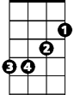

Em
G
C Dm
Happy Holiday - Happy holiday,
G C
May the calendar keep bringing
Dm G C
Happy holi-days to you
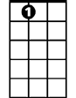
A7
C
It's the holiday season
Dm G Dm G
And Santa Claus is coming round
Dm G Em A7
The Christmas snow is white on the ground

Dm G Em A7
F
When old Santa gets into town
Dm G C
He'll be coming down the chimney, down
Dm G C
He'll be coming down the chimney, down

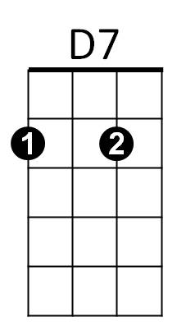
C
It's the holiday season
Dm G Dm G
And Santa Claus has got a toy
Dm G Em A7
For every good girl and good little boy
Dm G Em A7
He's a great big bundle of joy
Dm G C
When he’s coming down the chimney, down
BARITONE
Dm G C
C
When he’s coming down the chimney, down

Bridge:
F C F C
He'll have a big fat pack upon his back


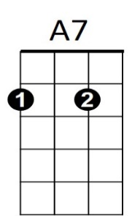
F C F C
F
D7
And lots of goodies for you and me
F C F C
So leave a peppermint stick for old St. Nick
D7 G
Hanging on the Christmas tree

C
It's the holiday season
Dm G Dm G
With the whoop-de-do and hickory dock
Dm G Em A7
And don't forget to hang up your sock
Dm G Em A7
'Cause just exactly at twelve o'clock
Dm G C
He'll be coming down the chimney, down
Dm G C
He'll be coming down the chimney, down

(Bridge)

C
It's the holiday season
Dm G Dm G
With the whoop-de-do and dickory dock
Dm G Em A7
And don't forget to hang up your sock
Dm G Em A7
'Cause just exactly at twelve o'clock
Dm G
He'll be coming down the chimney,
Dm G
Coming down the chimney,
Dm G C G
Coming down the chimney, down!

C Dm
Happy Holiday - Happy Holiday
G C
While the merry bells keep ringing
Dm G C


Happy Holida-ay to you!
Em
Dm
G

