


Happy Trails to You (Dale Evans, 1951)
C
G7
A7
C A7 G7
Happy trails to you until we meet a-gain
G7 Eb C
Happy trails to you, keep smiling until then
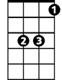


C7 F
Eb
C7
F
who cares about the clouds when we're to-gether
A7 D G7
Just sing a song and bring the sunny weather
C A7 Dm G7 C

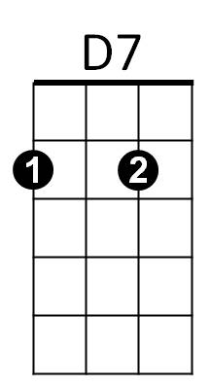

Happy trails to you till we meet a – gain.
D
Dm

F D7
Some trails are happy ones,
G
Others are blue.
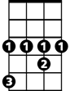
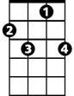


C C7
Ab
F7
Gm
Bb
It's the way you ride the trail that counts,
F
Here's a happy one for you.

F D7 C7
BARITONE
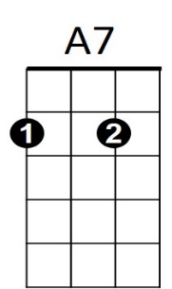
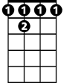
Happy trails to you until we meet a-gain
G7
C
F 7
C7 Ab F
Happy trails to you, keep smiling until then
F7 Bb
who cares about the clouds when we're to-gether
D7 G C7
Eb
F
C7
Just sing a song and bring the sunny weather.
F D7 Gm C7 F
Happy trails to you till we meet a – gain.
F D7 Gm C7 F
Happy trails to you till we meet a – gain.

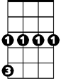
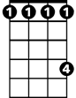
Bb
F 7
D
Dm
D7
Gm
Ab

