
Hark the Herald Angels Sing
C30 C
Lyrics by Charles Wesley (1739) and George Whitefield (1754); Music adapted from "Vaterland, in deinen Gauen" by Felix Mendelssohn (Festgesang, 1840) by William H. Cummings (1855)

Intro Chords of Chorus  C G  Hark the herald angels sing  C F C G C  "Glory to the new born King  D7  Peace on earth and mercy mild  G D7 G  God and sinners recon-ciled"  C G7 C  Joyful all ye nations rise_  C G7 C  Join the triumph of the skies  F A7 Dm A7 Dm  With an-gelic host pro-claim  G7 C G C  "Christ is born in Beth-le-hem"  Chorus  F A7 Dm A7 Dm  Hark the herald an - gels sing,  G7 C G7 C  "Glory to the new born King"  C G  Christ, by highest heaven adored;  C F C G C  Christ the everlasting Lord;  D7  Late in time behold him come,  G D7 G  Offspring of the favored one.  C G7 C  Veiled in flesh, the Godhead see;  C G7 C  Hail the incarnate Die-ty  F A7 Dm A7 Dm  Pleased as man with men to dwell,  G7 C G C  Jesus, our Emman-u-el. Chorus | C G  Hail! the heaven-born Prince of Peace.  C F C G C  Hail the son of Righteousness  D7  Light and life to all He brings,  G D7 G  Risen with healing in His wings  C G7 C  Mild He lays His glory by,  C G7 C  Born that man no more may die  F A7 Dm A7 Dm  Born to raise the sons of earth,  G7 C G C  Born to give them second birth. Chorus
 | 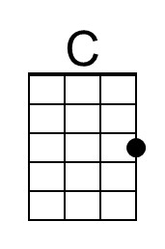 | 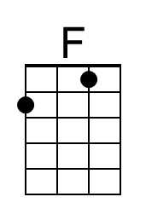 | 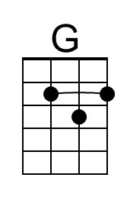 | 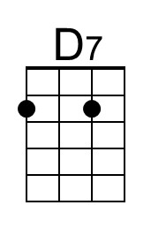
 | 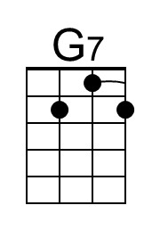 | 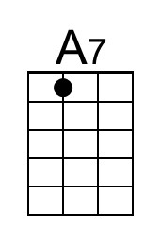 | 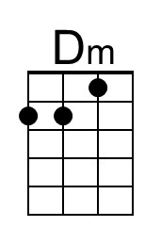
 | Baritone | 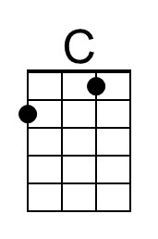 | 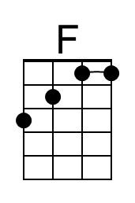 | 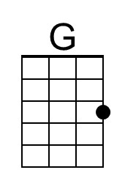
 | 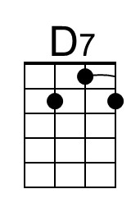 | 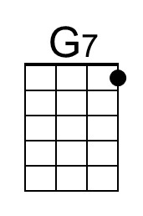 | 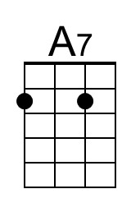 | 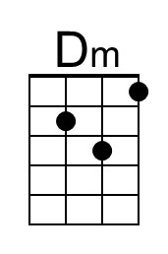

Hark the Herald Angels Sing
C30 G
Lyrics by Charles Wesley (1739) and George Whitefield (1754); Music adapted from "Vaterland, in deinen Gauen" by Felix Mendelssohn (Festgesang, 1840) by William H. Cummings (1855)

Intro Chords of Chorus  G D  Hark the herald angels sing  G C G D G  "Glory to the new born King  A7  Peace on earth and mercy mild  D A7 D  God and sinners recon-ciled"  G D7 G  Joyful all ye nations rise_  G D7 G  Join the triumph of the skies  C E7 Am E7 Am  With an-gelic host pro-claim  D7 G D G  "Christ is born in Beth-le-hem"  Chorus  C E7 Am E7 Am  Hark the herald an - gels sing,  D7 G D7 G  "Glory to the new born King"  G D  Christ, by highest heaven adored;  G C G D G  Christ the everlasting Lord;  A7  Late in time behold him come,  D A7 D  Offspring of the favored one.  G D7 G  Veiled in flesh, the Godhead see;  G D7 G  Hail the incarnate Die-ty  C E7 Am E7 Am  Pleased as man with men to dwell,  D7 G D G  Jesus, our Emman-u-el. Chorus | G D  Hail! the heaven-born Prince of Peace.  G C G D G  Hail the son of Righteousness  A7  Light and life to all He brings,  D A7 D  Risen with healing in His wings  G D7 G  Mild He lays His glory by,  G D7 G  Born that man no more may die  C E7 Am E7 Am  Born to raise the sons of earth,  D7 G D G  Born to give them second birth. Chorus
 |  | 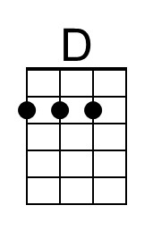
 |  | 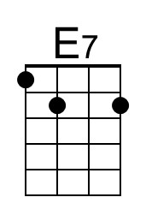 | 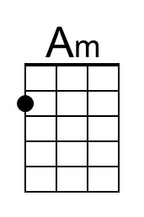
 | Baritone |  | 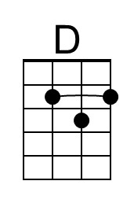
 |  |  | 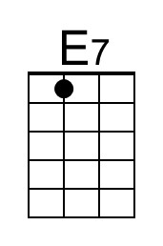 | 