
Hark the Herald Angels Sing
C
C 30

Intro: Last line of verse
C G
Hark the herald angels sing
C F C G C
"Glory to the new born King

D7
F
Peace on earth and mercy mild
G D7 G
God and sinners recon-ciled"
C G7 C
Joyful all ye nations rise_

C G7 C
G
Join the triumph of the skies
F A7 Dm A7 Dm
With an-gelic host pro-claim
G7 C G C
"Christ is born in Beth-le-hem"
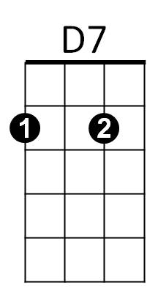
F A7 Dm A7 Dm
Hark the herald an - gels sing
G7 C G7 C
"Glory to the new born King"

C G

Christ, by highest heaven adored;
G7
C F C G C
Christ the everlasting Lord;
D7
Late in time behold him come,
G D7 G
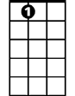
Offspring of the favored one.
A7
C G7 C
Veiled in flesh, the Godhead see;
C G7 C
Hail the incarnate Die-ty
F A7 Dm A7 Dm

Pleased as man with men to dwell,
Dm
G7 C G C
Jesus, our Emman-u-el
F A7 Dm A7 Dm
Hark the herald an - gels sing
G7 C G7 C
"Glory to the new born King"

C G
Hail! the heaven-born Prince of Peace.
C F C G C
Hail the son of Righteousness
D7
Light and life to all He brings,
G D7 G
Risen with healing in His wings
C G7 C
Mild He lays His glory by,
C G7 C
Born that man no more may die
F A7 Dm A7 Dm
Born to raise the sons of earth,
G7 C G C
Born to give them second birth
F A7 Dm A7 Dm
Hark the herald an - gels sing
G7 C G7 C
"Glory to the new born King"


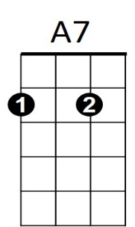

F
Dm
D7
C
G7
G
BARITONE

