Harvest Moon (Neil Young) Key C
Intro: G Em Gmaj7 Em 4x

C G G Em Gmaj7 Em (2x)
Come a little bit closer - Hear what I have to say
C G G Em Gmaj7 Em (2x)
Just like children sleepin - We could dream this night away.
C G G Em Gmaj7 Em (2x)
But there’s a full moon risin – Let’s go dancin in the light
C G

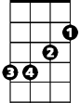
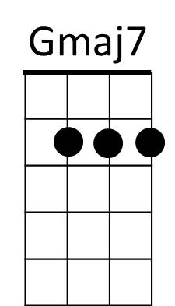
We know where the music’s playin - Let s go out and feel the night.
G
Em
G Em Gmaj7 Em (2x)

Chorus:
C D
Because I’m still in love with you



Am
C
D
Am
I want to see you dance again
C D
Because I’m still in love with you
G G Em Gmaj7 Em (2x)
On this harvest moon.

C G G Em Gmaj7 Em (2x)
When we were strangers - I watched you from afar
C G G Em Gmaj7 Em (2x)
When we were lovers - I loved you with all my heart.
C G G Em Gmaj7 Em (2x)
But now its gettin late - And the moon is climbin high
C G G Em Gmaj7 Em (2x)
I want to celebrate - See it shinin in your eye.

(Chorus)

G Em Gmaj7 Em (2x)
BARITONE
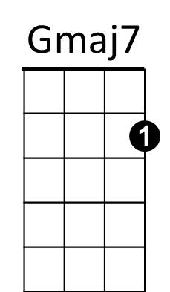


C
Am
D
Em
G

Harvest Moon (Neil Young) Key F
Intro: C Am Cmaj7 Am 4x

F C C Am Cmaj7 Am (2x)
Come a little bit closer - Hear what I have to say
F C C Am Cmaj7 Am (2x)
Just like children sleepin - We could dream this night away.
F C C Am Cmaj7 Am (2x)
But there’s a full moon risin – Let’s go dancin in the light
F C
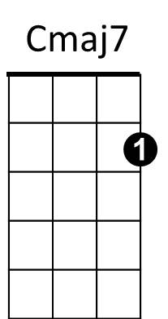
We know where the music’s playin - Let s go out and feel the night.
G
Dm
F
Am
C
C Am Cmaj7 Am (2x)

Chorus:
F G
Because I’m still in love with you
Dm
I want to see you dance again
F G
Because I’m still in love with you
C C Am Cmaj7 Am (2x)
On this harvest moon.

F C C Am Cmaj7 Am (2x)
When we were strangers - I watched you from afar
F C C Am Cmaj7 Am (2x)
When we were lovers - I loved you with all my heart.
F C C Am Cmaj7 Am (2x)
But now its gettin late - And the moon is climbin high
F C C Am Cmaj7 Am (2x)
I want to celebrate - See it shinin in your eye.

(Chorus)

C Am Cmaj7 Am (2x)
BARITONE


C
Am
Cmaj7
F
G
Dm

Harvest Moon (Neil Young) Key Bb
Intro: F Dm Fmaj7 Dm 4x

Bb F F Dm Fmaj7 Dm (2x)
Come a little bit closer - Hear what I have to say
Bb F F Dm Fmaj7 Dm (2x)
Just like children sleepin - We could dream this night away.
Bb F F Dm Fmaj7 Dm (2x)
But there’s a full moon risin – Let’s go dancin in the light
Bb F
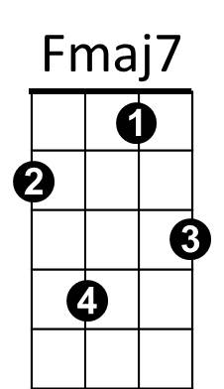
We know where the music’s playin - Let s go out and feel the night.
Bb
C
Gm
Dm
F
F Dm Fmaj7 Dm (2x)

Chorus:
Bb C
Because I’m still in love with you
Gm
I want to see you dance again
Bb C
Because I’m still in love with you
F F Dm Fmaj7 Dm (2x)
On this harvest moon.

Bb F F Dm Fmaj7 Dm (2x)
When we were strangers - I watched you from afar
Bb F F Dm Fmaj7 Dm (2x)
When we were lovers - I loved you with all my heart.
Bb F F Dm Fmaj7 Dm (2x)
But now its gettin late - And the moon is climbin high
Bb F F Dm Fmaj7 Dm (2x)
I want to celebrate - See it shinin in your eye.

(Chorus)

F Dm Fmaj7 Dm (2x)
BARITONE
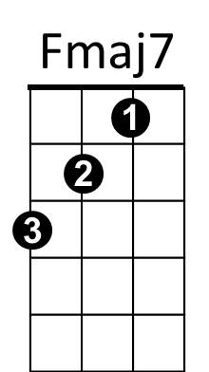
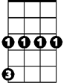
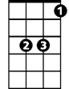
Dm
C
F
Gm
Bb

Harvest Moon (Neil Young) Key G
Intro: D Bm Dmaj7 Bm 4x

G D D Bm Dmaj7 Bm (2x)
Come a little bit closer - Hear what I have to say
G D D Bm Dmaj7 Bm (2x)
Just like children sleepin - We could dream this night away.
G D D Bm Dmaj7 Bm (2x)
But there’s a full moon risin – Let’s go dancin in the light
G D
We know where the music’s playin - Let s go out and feel the night.
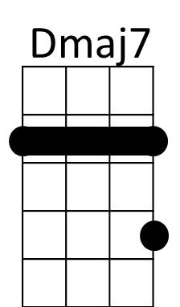
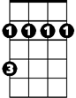
D Bm Dmaj7 Bm (2x)
Bm
D

Chorus:
G A
Because I’m still in love with you
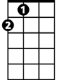
Em
G
Em
A
I want to see you dance again
G A
Because I’m still in love with you
D D Bm Dmaj7 Bm (2x)
On this harvest moon.

G D D Bm Dmaj7 Bm (2x)
When we were strangers - I watched you from afar
G D D Bm Dmaj7 Bm (2x)
When we were lovers - I loved you with all my heart.
G D D Bm Dmaj7 Bm (2x)
But now its gettin late - And the moon is climbin high
G D D Bm Dmaj7 Bm (2x)
I want to celebrate - See it shinin in your eye.

(Chorus)

D Bm Dmaj7 Bm (2x)
BARITONE
Em
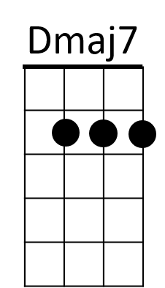
A
G
Bm
D

