
Have Yourself a Merry Little Christmas
C70 C
(Hugh Martin and Ralph Blane, 1943)
Have Yourself a Merry Little Christmas by Judy Garland from ‘Meet Me in St. Louis’ (1944)

Intro C - F - Dm - G7  C Am Dm G7 C Am Dm G7  Have yourself a merry little Christmas, Let your heart be light,  C Am Dm G7 E7 A7 D G7  Next year all our troubles will be out of sight.  C Am Dm G7 C Am Dm G7  Have yourself a merry little Christmas, Make the Yuletide gay,  C Am Dm E7 C7  Next year all our troubles will be miles away.  F Em Dm G7 C  Once again as in olden days happy golden days of yore,  Am Em  Faithful friends who are dear to us  G D Dm G7  Will be near to us once more.  C Am Dm G7 C Am Dm G7  Someday soon we all will be together, if the Fates allow,  C Am Dm G Am C7  Until then we’ll have to muddle through somehow,  F Dm G7 C F Dm C  So have yourself a merry little Christmas now.  F Dm G7 C F Dm C  And have yourself a merry little Christ-mas now. |  |  |  |  |  |  | 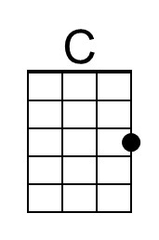 | 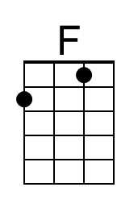
 |  |  |  |  |  |  | 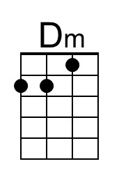 | 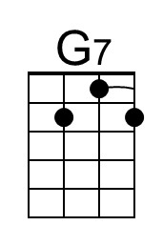
 |  |  |  |  |  |  | 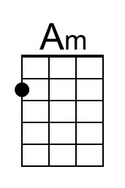 | 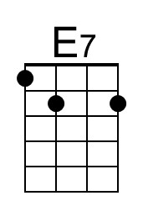
 |  |  |  |  |  |  | 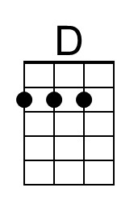 | 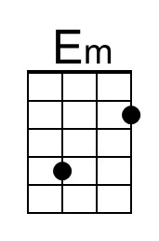
 |  |  |  |  |  |  | 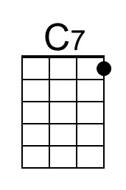 | 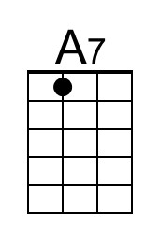
 |  |  |  |  |  |  | 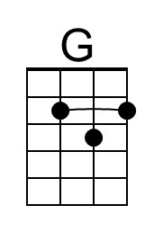
Baritone | 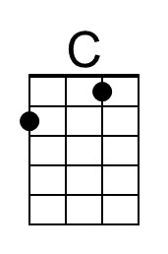 | 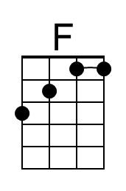 | 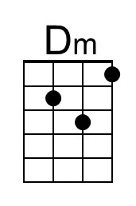 | 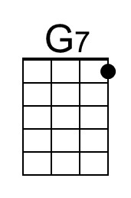 | 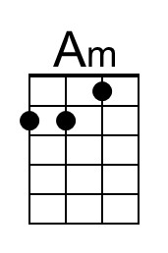 | 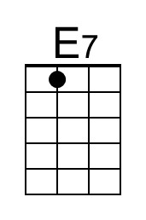
 | 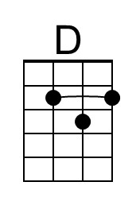 | 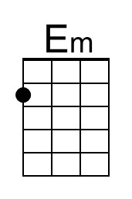 | 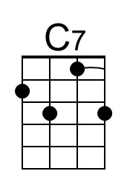 | 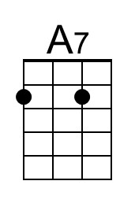 | 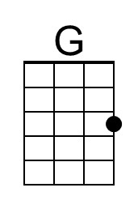

Have Yourself a Merry Little Christmas
C70 G
(Hugh Martin and Ralph Blane, 1943)
Have Yourself a Merry Little Christmas by Judy Garland from ‘Meet Me in St. Louis’ (1944)

Intro G - C - Am - D7

G Em Am D7 G Em Am D7
Have yourself a merry little Christmas, let your heart be light,
G Em Am D7 B7 E7 A D7
Next year all our troubles will be out of sight.
G Em Am D7 G Em Am D7
Have yourself a merry little Christmas, make the Yuletide gay,
G Em Am B7 G7
Next year all our troubles will be miles away.

C Bm Am D7 G
Once again as in olden days happy golden days of yore,
Em Bm
Faithful friends who are dear to us
D A Am D7
Will be near to us once more.

G Em Am D7 G Em Am D7
Someday soon we all will be together, if the Fates allow,
G Em Am D Em G7
Until then we’ll have to muddle through somehow,
C Am D7 G C Am G
So have yourself a merry little Christmas now.
C Am D7 G C Am G
And have yourself a merry little Christ-mas now.
 |  |  |  |  |  |  |  | 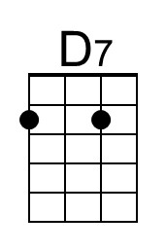
 |  |  |  |  |  |  |  | 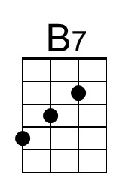
 |  |  |  |  |  |  | 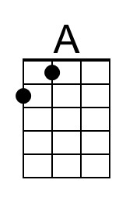 | 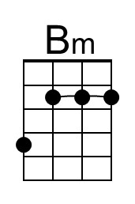
Baritone |  |  |  | 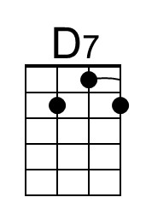 |  | 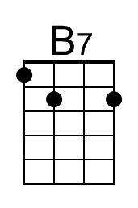
 | 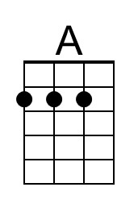 | 