Have Yourself a Merry Little Christmas
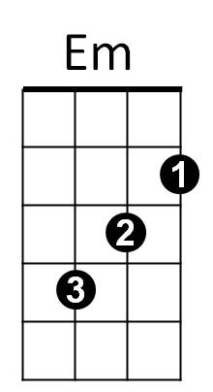


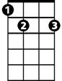



D
G7
E7
C
Dm
F
Intro: C - F - Dm - G7

C Am Dm G7
Have yourself a merry little Christmas,
C Am Dm G7

Let your heart be light,
Am
C Am Dm G7 E7 A7 D G7
Next year all our troubles will be out of sight.

C Am Dm G7
Have yourself a merry little Christmas,

C Am Dm G7
C7
Make the Yuletide gay,
C Am Dm E7 C7
Next year all our troubles will be miles away.

F Em Dm G7 C
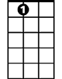

Once again as in olden days happy golden days of yore,
A7
G
Am Em
Faithful friends who are dear to us
G D Dm G7
Will be near to us once more.

C Am Dm G7
Someday soon we all will be together,
C Am Dm G7
If the Fates allow,
C Am Dm G Am C7
Until then we’ll have to muddle through somehow,
F Dm G7 C F Dm C
So have yourself a merry little Christmas now.

F Dm G7 C F Dm C
And have yourself a merry little Christ-mas now.

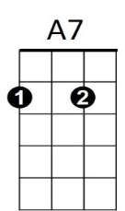
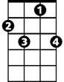


C7
BARITONE
G
F
C
Dm
G7
Em
D
E7
Am

