Heart Like a Wheel (Kate and Anna McGarrigle)
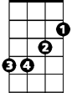Intro: F G G7 C
Dm
F
Em
G7
G
C

C G
Some say a heart is just like a wheel,
Em Am
When you bend it, you can't mend it.
Dm Am Dm
And my love for you is like a sinking ship
Am
F G G7 C
And my heart is on that ship out in mid o - cean.
F G G7 C

C G
They say that death is a tragedy;
Em Am
It comes once and it's over.
Dm Am Dm
But my only wish is for that deep dark abyss,
F G G7 C
'Cause what's the use of living with no true lo - ver?
F G G7 C

C G
When harm is done no love can be won,
BARITONE
 Em Am
G7
G
F
I know it happens frequently.
Dm Am Dm
What I can't understand, Oh please God hold my hand,
F G G7 C
Why it had to happen to me - e.

Refrain:
Am
Em
C
Am Dm G
And it's only love, and it's only love.
Am Dm G G7
That can wreck a human being and turn him inside out

Instrumental Verse
Dm

C G
Some say a heart is just like a wheel,
Em Am
When you bend it, you can't mend it.
Dm Am Dm
And my love for you is like a sinking ship
F G G7 C
And my heart is on that ship out in mid o - cean
F G G7 C F C

Heart Like a Wheel (Kate and Anna McGarrigle)
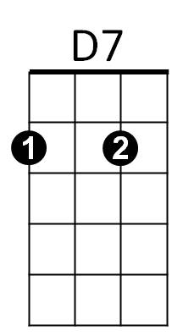
Intro: C D D7 G
G
D
C

G D
Some say a heart is just like a wheel,
Bm Em
When you bend it, you can't mend it.
Am Em Am
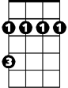And my love for you is like a sinking ship
Bm
Em
Am
C D D7 G
And my heart is on that ship out in mid o - cean.
C D D7 G

G D
They say that death is a tragedy;
Bm Em
It comes once and it's over.
Am Em Am
But my only wish is for that deep dark abyss,
C D D7 G
'Cause what's the use of living with no true lo - ver?
C D D7 G

G D
When harm is done no love can be won,
BARITONE
Bm Em
C
D
D7
I know it happens frequently.
Am Em Am
What I can't understand, Oh please God hold my hand,
C D D7 G
Why it had to happen to me - e.

Refrain:
Em
Bm
G
Em Am D
And it's only love, and it's only love.
Em Am D D7
That can wreck a human being and turn him inside out

Instrumental Verse
Am
G D
Some say a heart is just like a wheel,
Bm Em
When you bend it, you can't mend it.
Am Em Am
And my love for you is like a sinking ship
C D D7 G
And my heart is on that ship out in mid o - cean
C D D7 G C G

