Heart of Gold (Neil Young)

Intro: Em ////// D // Em / (3x)
Em G C G Em ////// D // Em /

Em C D G Em
I want to live, I want to give
C D G Em
I've been a miner for a heart of gold
C D G Em
It's these expressions I never give
G
That keep me searchin' for a heart of gold
C G
And I'm gettin' old
Em G
Keeps me searchin’ for a heart of gold
C G
And I'm gettin' old

Em ////// D // Em /

Em C D G Em
BARITONE
I've been to Hollywood, I've been to Redwood
C D G Em
I crossed the ocean for a heart of gold
C D G Em
I've been in my mind, it's such a fine line
G
That keeps me searching for a heart of gold
C G
And I'm getting old
Em G
Keeps me searchin’ for a heart of gold
C G
And I'm gettin' old

G D Am G / G Am C G / G D G

Em D Em
Keep me searchin’ for a heart of gold
D Em
You keep me searchin’ and I'm growin’ old
D Em
Keep me searchin’ for a heart of gold
G C G



I've been a miner for a heart of gold... Ahh ahhhh
Em
D
G
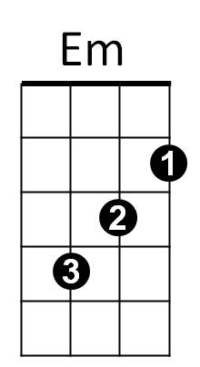

C
Am
G
D



C
Am

