Hello Mary Lou (Cayet Mangiaracina / Gene Pitney) Key C


Chorus:
F
G

C F
C
BARITONE
Hello Mary Lou, Goodbye heart
C G G7
Sweet Mary Lou, I'm so in love with you
C E7 Am
I knew Mary Lou, we'd never part
C G C F C

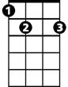

So hello Mary Lou, Goodbye heart"
G7
E7
Am

C
You passed me by one sunny day
F
Flashed those big brown eyes my way
C G
And ooh I wanted you forever more
C
Now I'm not one that gets around
F
I swear my feet stuck to the ground
C G C F C
And though I never did meet you before - I said

(Chorus)


C
G
F
C
I saw your lips I heard your voice
F
Believe me I just had no choice
C G
Wild horses couldn't make me stay away
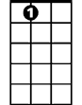


C
E7
G7
Am
I thought about a moonlit night
F
My arms around you, good an' tight
C G C F C
That’s all I had to see for me to say – hey hey

(Chorus)

C G C F C
So hello Mary Lou, Goodbye heart"
C G C F C
Yes, hello Mary Lou, Goodbye heart"

Hello Mary Lou (Cayet Mangiaracina / Gene Pitney) Key G
Chorus:

G C
D
C
G
Hello Mary Lou, Goodbye heart
G D D7
Sweet Mary Lou, I'm so in love with you
G B7 Em
I knew Mary Lou, we'd never part
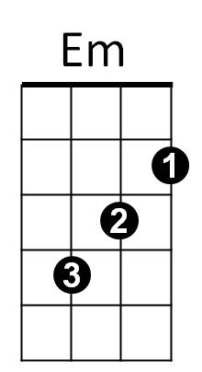
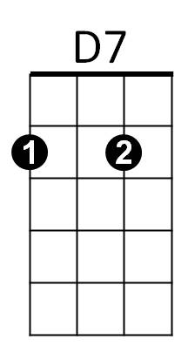
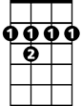
G D G C G
B7
So hello Mary Lou, Goodbye heart"

G
You passed me by one sunny day
C
Flashed those big brown eyes my way
G D
And ooh I wanted you forever more
G
Now I'm not one that gets around
C
I swear my feet stuck to the ground
G D G C G
And though I never did meet you before - I said

(Chorus)
BARITONE
G
G
D
C
I saw your lips I heard your voice
C
Believe me I just had no choice
G D
Wild horses couldn't make me stay away
G
B7
I thought about a moonlit night
Em
D7
C
My arms around you, good an' tight
G D G C G
That’s all I had to see for me to say – hey hey

(Chorus)

G D G C G
So hello Mary Lou, Goodbye heart"
G D G C G
Yes, hello Mary Lou, Goodbye heart"

Hello Mary Lou (Cayet Mangiaracina / Gene Pitney) Key F
Chorus:
F Bb
Hello Mary Lou, Goodbye heart
F C C7
Sweet Mary Lou, I'm so in love with you
A7
C7
Dm
C
Bb
F
F A7 Dm
I knew Mary Lou, we'd never part
F C F Bb F
So hello Mary Lou, Goodbye heart"

F
You passed me by one sunny day
Bb
Flashed those big brown eyes my way
F C
And ooh I wanted you forever more
F
Now I'm not one that gets around
Bb
I swear my feet stuck to the ground
F C F Bb F
And though I never did meet you before - I said

(Chorus)

F
I saw your lips I heard your voice
Bb
Believe me I just had no choice
F C
Wild horses couldn't make me stay away
BARITONE
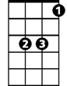
F
Bb
F
C
I thought about a moonlit night
Bb
My arms around you, good an' tight
F C F Bb F
That’s all I had to see for me to say – hey hey
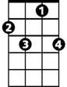
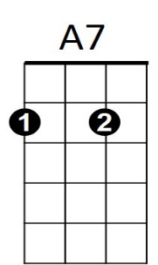

C7
Dm
(Chorus)

F C F Bb F
So hello Mary Lou, Goodbye heart"
F C F Bb F
Yes, hello Mary Lou, Goodbye heart"

