Here Comes Santa Claus (Gene Autry and O. Haldeman)
C08
C G7


Here comes Santa Claus, here comes Santa Claus, right down Santa Claus Lane.
C
G7
C C7
Vixen and Blitzen and all his reindeer are pulling on the rein.
F Em Dm G7 C
Bells are ringing, children singing - All is merry and bright.
F C A7 Dm G7 C


Hang your stockings and say your prayers, 'Cause Santa Claus comes tonight.
Dm
C7

C G7
Here comes Santa Claus, here comes Santa Claus, right down Santa Claus Lane.
C C7
He's got a bag that is filled with toys for the boys and girls again.
F Em Dm G7 C
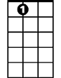
Hear those sleigh bells jingle jangle, what a beautiful sight.
A7
Dm
F C A7 Dm G7 C
Jump in bed, cover up your head, 'Cause Santa Claus comes tonight!

C G7
Here comes Santa Claus, here comes Santa Claus, right down Santa Claus Lane.
C C7
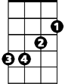
He doesn’t care if you’re rich or poor, he loves you just the same
Em
A7
F Em Dm G7 C
Santa Claus knows that we’re all God’s children, that makes everything right
F C A7 Dm G7 C
So fill your hearts with Christmas cheer, 'cause Santa Claus comes tonight

C G7

Here comes Santa Claus, here comes Santa Claus, right down Santa Claus Lane.
F
C C7
He'll come around when chimes ring out, it's Christmas time again
F Em Dm G7 C
Peace on earth will come to all, if we just follow the light
F C A7 Dm G7 C
So let's give thanks to the Lord above, 'cause Santa Claus comes tonight

(Repeat First Verse)

BARITONE

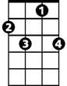

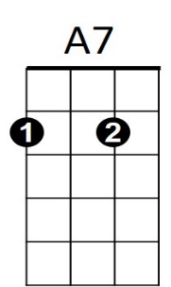

C
G7
Em
C7
Dm
F

