Here Comes That Rainy Day Feeling Again Key C
(Roger Frederick Cook / Roger John Reginald Greenaway / Tony Macaulay)



INTRO: C Bb (x2) C
F
C
Bb

C Bb
Here comes that rainy day feeling again.
C Bb
And soon my tears they will be falling like rain.
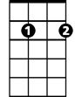
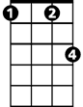
F
Em7
Fm
It always seems to be a Monday,
Fm C Em7
Left over memories of Sunday, always spent with you..
F G C


Before the clouds appeared, and took away my sunshi -ine.
G7
G

C Bb
Here comes that rainy day feeling again.
C Bb
And I'll be dreaming of you Baby, in vain.
F
Your face is always on my mind girl,
Fm C Em7
BARITONE
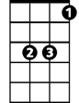
I'm hoping soon you're gonna find, girl..your way back to me..
C
Bb
F G C
Cause if you say you'll stay, the rainy days will go away.

C Bb

Fm C
Misty morning eyes, I'm trying to disguise the way I feel..
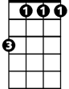
Fm
F
But I just can't hide it.
Fm
People seem to know, the loneliness must show..
C G G7
I'm thinking of my pride, but breaking up inside, girl, whoa -oh-oh.

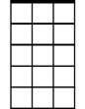
G7
Em7
G
(First Verse)

OUTRO:
C Bb
Here comes that rainy day feeling again..(x3)(Fade.)

Here Comes That Rainy Day Feeling Again Key G
(Roger Frederick Cook / Roger John Reginald Greenaway / Tony Macaulay)
F
BARITONE
INTRO: G F (x2) G
C
G

G F
Here comes that rainy day feeling again.
G F
And soon my tears they will be falling like rain.
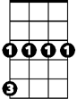
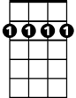
C
Cm
Bm7
It always seems to be a Monday,
Cm G Bm7
Left over memories of Sunday, always spent with you..
C D G
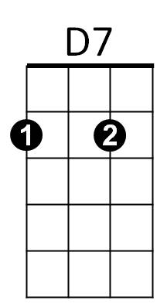
Before the clouds appeared, and took away my sunshi -ine.

D
G F
Here comes that rainy day feeling again.
G F
And I'll be dreaming of you Baby, in vain.
C
Your face is always on my mind girl,
Cm G Bm7
F
I'm hoping soon you're gonna find, girl..your way back to me..
G
C D G
Cause if you say you'll stay, the rainy days will go away.

G F

Cm G
Misty morning eyes, I'm trying to disguise the way I feel..
Fm
C
But I just can't hide it.
Cm
People seem to know, the loneliness must show..
G D D7
I'm thinking of my pride, but breaking up inside, girl, whoa -oh-oh.
Bm7
D7
D
(First Verse)

OUTRO:
G F
Here comes that rainy day feeling again..(x3)(Fade.)

