Here Comes the Sun (George Harrison) Key G
Intro: (melody for 2d and 3d lines of verse)
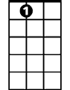

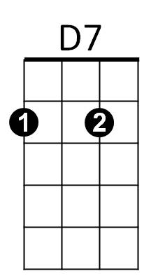




G
A7
Bb
C
G
F
Am
Here comes the sun, (do-do-do-do)
C A7 G C G Am G D7 / G D7
Here comes the sun, and I say: "It's allright!"

G C D7
Little darling, it's been a long, cold, lonely winter
G C D7
Little darling, it feels like years since it's been here
G
Here comes the sun, (do-do-do-do)
C A7 G C G Am G D7 / G D7
Here comes the sun, and I say: "It's allright!"

G C D7
Little darling, the smile’s returning to their faces
G C D7
Little darling, it seems like years since it's been here
G
Here comes the sun, (do-do-do-do)
C A7 G C G Am G D7 / G D7
Here comes the sun, and I say: "It's allright!"

Bb F C G D7


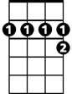

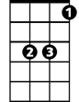
Bb F C G D7 Bb F C G D7
BARITONE
Am
C
A7
D7
F
G
Bb
Sun, sun, sun, here it comes Sun, sun, sun, here it comes
Bb F C G D7 Bb F C G D7
Sun, sun, sun, here it comes Sun, sun, sun, here it comes
Bb F C G D7
Sun, sun, sun, here it comes

G D7

G C D7
Little darling, I feel that ice is slowly melting
G C D7
Little darling, it seems like years since it's been clear
G
Here comes the sun, (do-do-do-do)
C A7 G C G Am G D7
Here comes the sun, and I say: "It's allright!"
G
Here comes the sun, (do-do-do-do)
C A7 G C G Am G D7
Here comes the sun, and I say: "It's allright!"
G C G Am G D7 / Bb F C G
"It's allright!"

Here Comes the Sun (George Harrison) Key D
Intro: (melody for 2d and 3d lines of verse)
D
Here comes the sun,
G E7 D G D Em7 D A7
Here comes the sun, and I say: "It's allright!"

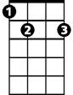
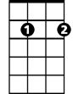
D G A7
D
G
E7
C
Em7
A7
F
Little darling, it's been a long, cold, lonely winter
D G A7
Little darling, it feels like years since it's been here
D
Here comes the sun, (do-do-do-do)
G E7 D G D Em7 D A7
Here comes the sun, and I say: "It's allright!"

D A7

D G A7
Little darling, the smile’s returning to their faces
D G A7
Little darling, it seems like years since it's been here
D
Here comes the sun, (do-do-do-do)
G E7 D G D Em7 D A7
Here comes the sun, and I say: "It's allright!"

D A7 F C G D A7
BARITONE
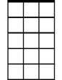
F C G D A7 F C G D A7
F
C
A7
Em7
E7
G
D
Sun, sun, sun, here it comes Sun, sun, sun, here it comes
F C G D A7 F C G D A7
Sun, sun, sun, here it comes Sun, sun, sun, here it comes
F C G D A7
Sun, sun, sun, here it comes

D A7

D G A7
Little darling, I feel that ice is slowly melting
D G A7
Little darling, it seems like years since it's been here
D
Here comes the sun, (do-do-do-do)
G E7 D G D Em7 D A7
Here comes the sun, and I say: "It's allright!"
D
Here comes the sun, (do-do-do-do)
G E7 D G D Em7 D A7
Here comes the sun, and I say: "It's allright!"
D G D Em7 D A7 / F C G D
"It's allright!"

