Here, There and Everywhere (John Lennon / Paul McCartney)
C Em Eb Dm G7


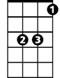
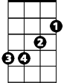

To lead a better life ~ I need my love to be here
G7
Dm
Eb
Em
C

C Dm Em F C Dm
Here, making each day of the year
Em7 F Bm7 E7
Changing my life with a wave of her hand
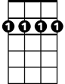
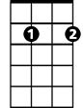
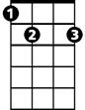

Bm7 E7 Am Dm G7
Bm7
Em7
E7
F
Nobody can deny that there's something there

C Dm Em F C Dm
There, running my hands through her hair
Em7 F Bm7 E7
Both of us thinking how good it can be
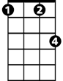
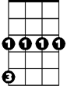
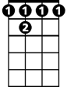

Bm7 E7 Am Dm G7
Fm
Cm
Bb7
Am
Someone is speaking but she doesn't know he's there

Bb7 Eb Cm
I want her everywhere
Fm G7 Cm
And if she's beside me I know I need never care
Fm G7
But to love her is to need her
BARITONE
C Dm Em F C Dm
Em


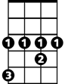
Everywhere, knowing that love is to share
G7
Dm
Eb
C
Em7 F Bm7 E7
Each one believing that love never dies
Bm7 E7 Am Dm G7
Watching her eyes and hoping I'm always there

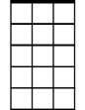

Bb7 Eb Cm
Em7
Bm7
F
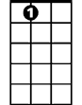
I want her everywhere
E7
Fm G7 Cm
And if she's beside me I know I need never care
Fm G7
But to love her is to need her

C Dm Em F C Dm
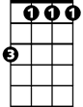
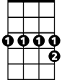
Everywhere, knowing that love is to share
Fm
Cm
Bb7
Am
Em7 F Bm7 E7
Each one believing that love never dies
Bm7 E7 Am Dm G7
Watching her eyes and hoping I'm always there
C Dm Em F
I will be there, and everywhere
C Dm Em F C
Here, there and everywhere

