Hernando’s Hideaway (Richard Adler & Jerry Ross, 1954) (C)

G7 Cm  I know a dark secluded place, a place where no one knows your face.  G7 Cm G7 Cm G7 Cm  A glass of wine, a fast embrace, it's called Her-nando's Hide-a-way. O - le!  G7 Cm  All you see are silhouettes, and all you'll hear are castanets.  G7 Cm G7 Cm G7 Cm  And no one cares how late it gets, not at Her-nando's Hide-a-way. O - le!  Bridge  Fm Cm  Ooooooh! At the Golden Fingerbowl or any place you go  Fm Cm  Ooooooh! You will meet your Uncle Max and everyone you know,  C7 Fm  Ooooooh! But if you'll go to the spot that I am thinking of,  D7 D7 G7 F#7 G7  You will be free to gaze at me and talk of love.  G7 Cm  Just knock three times and whisper low, that you and I were sent by Joe,  G7 Cm G7 Cm G7 Cm  Then strike a match and you will know You're in Her-nando's Hide-away. O - le!  Repeat from Bridge |  |  |  |  |  |  |  | 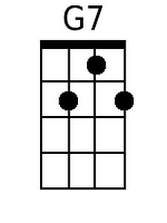
 |  |  |  |  |  |  |  | 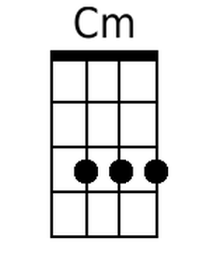
 |  |  |  |  |  |  |  | 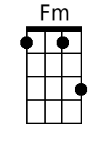
 |  |  |  |  |  |  |  | 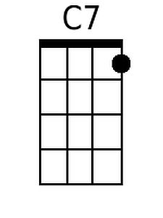
 |  |  |  |  |  |  |  | 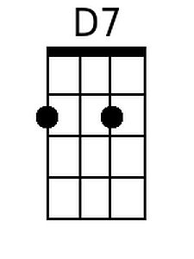
 |  |  |  |  |  |  |  | 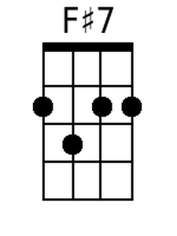
Baritone
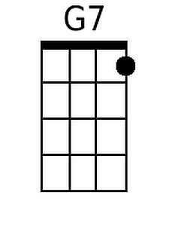 | 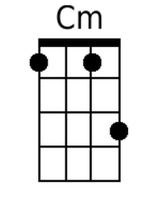 | 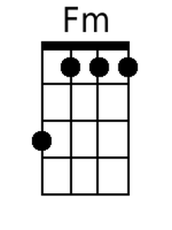 | 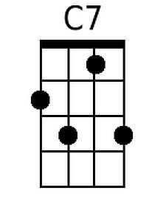 | 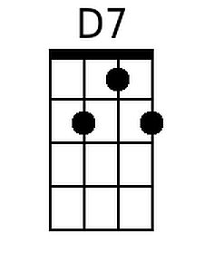 | 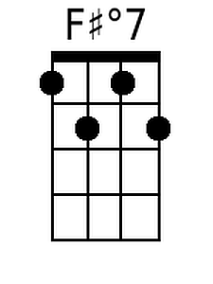

Hernando’s Hideaway (Richard Adler & Jerry Ross, 1954) (F)

C7 Fm
I know a dark secluded place, a place where no one knows your face.
C7 Fm C7 Fm C7 Fm
A glass of wine, a fast embrace, it's called Her-nando's Hide-a-way. O - le!
C7 Fm
All you see are silhouettes, and all you'll hear are castanets.
C7 Fm C7 Fm C7 Fm
And no one cares how late it gets, not at Her-nando's Hide-a-way. O - le!

Bridge
Bbm Fm
Ooooooh! At the Golden Fingerbowl or any place you go
Bbm Fm
Ooooooh! You will meet your Uncle Max and everyone you know,
F7 Bbm
Ooooooh! But if you'll go to the spot that I am thinking of,
G7 G7 C7 B7 C7
You will be free to gaze at me and talk of love.

C7 Fm
Just knock three times and whisper low, that you and I were sent by Joe,
C7 Fm C7 Fm C7 Fm
Then strike a match and you will know You're in Her-nando's Hide-away. O - le!

Repeat from Bridge

 |  |  |  |  |  |  |  | 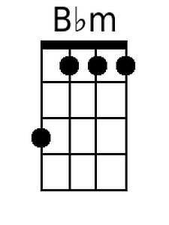
 |  |  |  |  |  |  |  | 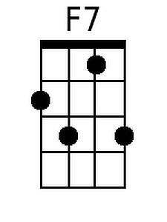
 |  |  |  |  |  |  |  | 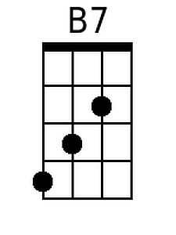
Baritone
 |  | 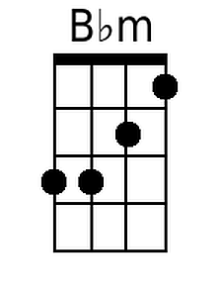 | 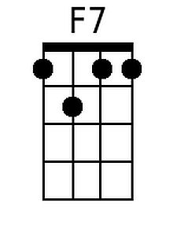 |  | 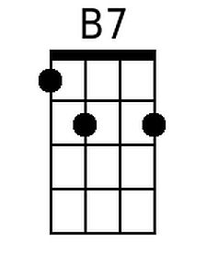

Alternate chords for C7 and G7 in bridge (C Tuning):

0212 4535 3433 3434 3433 2322 3433 0001
G7 G7* C7* C7b9 C7* B7* C7* C7
You will be free ____ to gaze at me ____ and talk of lo - ove.

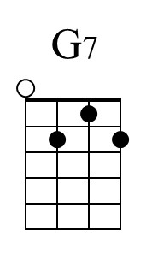  0212 | 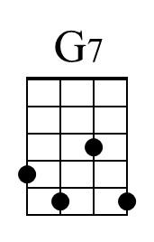  4535 | 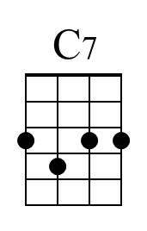  3433 | 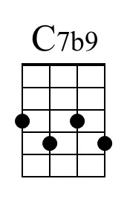  3434 | 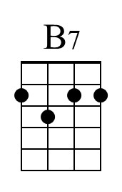  2322 | 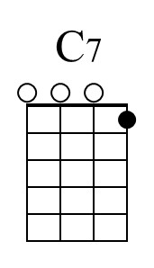  0001

