Hey Baby (Bruce Channel / Margaret Cobb) Key C




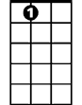


Intro: C Am F G 4x
C
Am
F
G
A7
C7
D
Chorus:
C Am F G C Am F
Hey, hey baby,
G C Am F G C Am F G

I wanna know if you'll be my girl.
G7
C Am F G C Am F
Hey, hey baby,
G C Am F G C F C C7
I wanna know if you'll be my girl.

F
When I saw you walking down the street.
C C7
I said that's the kind of girl I'd like to meet.
F
She is so pretty, Lord, she's fine.
G G7
I'm gonna make her mine all mine.

(Chorus)

A7 D
When you turned and walked away, that's when I want to say
G C
Come on a baby, give me a whirl, I wanna know if you'll be my girl.

(Chorus)

A7 D
When you turned and walked away, that's when I want to say
G C
Come on a baby, give me a whirl, I wanna know if you'll be my girl.

(Chorus) (fade out at end)
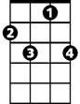
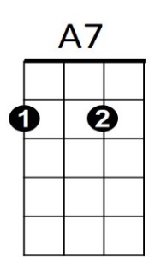


BARITONE
C7
D
G7
G
F
Am
C

Hey Baby (Bruce Channel / Margaret Cobb) Key G
Intro: G Em C D 4x
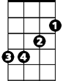
Chorus:
Em
C
D
G
G Em C D G Em C
Hey, hey baby,
D G Em C D G Em C D
I wanna know if you'll be my girl.
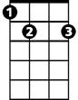
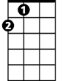
G Em C D G Em C
E7
A
G7
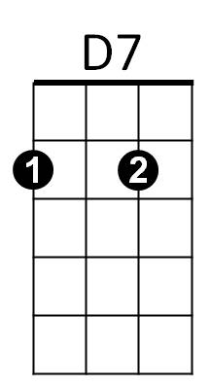
Hey, hey baby,
D G Em C D G C G G7
I wanna know if you'll be my girl.

C
When I saw you walking down the street.
G G7
I said that's the kind of girl I'd like to meet.
C
She is so pretty, Lord, she's fine.
D D7
I'm gonna make her mine all mine.

(Chorus)

E7 A
When you turned and walked away, that's when I want to say
D G
Come on a baby, give me a whirl, I wanna know if you'll be my girl.

(Chorus)

E7 A
When you turned and walked away, that's when I want to say
D G
Come on a baby, give me a whirl, I wanna know if you'll be my girl.

(Chorus) (fade out at end)
D7
E7
G
Em
C
D
G7
A
BARITONE

