High Hopes (Jimmy Van Heusen / Sammy Cahn)

C
Next time you're found
Gdim
With your chin on the ground
Dm
there's a lot to be learned –
G7 C Am Dm G7
So look around
C F
Just what makes that little old ant
G7 C
Think he'll move that rubber tree plant
Gdim Dm Cdim
Anyone knows an ant, can't
Dm G7 C
Move a rubber tree plant
Chorus:
G7 C7 F
But he's got high hopes
Cdim C
He's got high hopes
D7 G7
He's got high apple pie in the sky hopes
C
So any time you're gettin' low
C7 F CdIm
'Stead of lettin' go, just remember that ant
C Gdim Dm G7 C
Oops, there goes another rubber tree plant
C Gdim Dm G7 C

Oops, there goes another rubber tree plant
F
C Gdim Dm G7 C
Oops, there goes another rubber tree plant
BARITONE

C Gdim
When troubles call and your back's to the wall
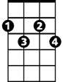


Dm
Gdim
C
Dm
G7
There a lot to be learned –
G7 C Am Dm G7
That wall could fall
C F
Once there was a silly old ram

G7 C
D7
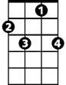
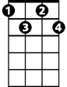

Thought he'd punch a hole in a dam
C7
Cdim
F
Gdim Dm Cdim
No one could make that ram, scram
Dm G7 C
He kept buttin' that dam

(Chorus)
C
So any time you're feelin' bad
C7 F Cdim
'Stead of feelin' sad, just remember that ram
C Dm G7 C
Oops, there goes a billion kilowatt dam
C Dm G7 C
Oops, there goes a billion kilowatt dam
C Dm G7 C
Oops, there goes a billion kilowatt dam
(Chorus)
G7 C
A problem’s just a toy balloon
C7
They'll be bursting soon,
F Cdim
They're just bound to go pop
C Gdim Dm G7 C
Oops, there goes a-nother problem kerplop
C Gdim Dm G7 C
Oops, there goes a-nother problem kerplop
C Gdim Dm G7 C
Oops, there goes a-nother problem kerplop
G7 C


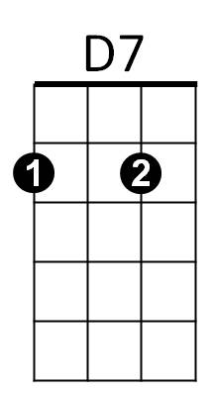
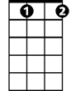

Ker – plop!
Am
Cdim
Am
C7
Dm
Gdim
G7
C

