Hold Me Now (Alannah Joy Currie, Joseph Martin Leeway & Tom Bailey) (C)

Intro: C Am F G  C Am  I have a picture, pinned to my wall.  F G  An image of you and of me and we're laughing and loving it all.  C Am  Look at our life now, tattered and torn.  F  We fuss and we fight and delight in the tears  G  that we cry until dawn Oh-oh, oh-oh  Chorus  C Am  Hold me now, Woah-oh, warm my heart  F G  Stay with me, let loving start (let loving start) ______  C Am  You say I'm a dreamer, we're two of a kind  F G  Both of us searching for some perfect world we know we'll never find  C Am  So per-haps I should leave here, yeah yeah, go far away  F  But you know that there's nowhere that I'd rather be  G  than with you here today Oh-oh, oh-oh. Chorus (2x)  C Am  You ask if I love you, well what can I say?  F G  You know that I do and if this is just one of those games that we play  C Am  So I'll sing you a new song, please don't cry anymore  F  And then I'll ask your forgiveness,  G  though I don't know just what I'm asking it for.  Oh-oh, oh-oh. Chorus (3x) (End on C) |  |  |  |  |  |  |  |  | 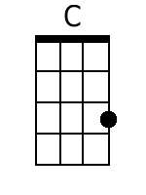
 |  |  |  |  |  |  |  |  | 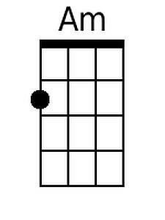
 |  |  |  |  |  |  |  |  | 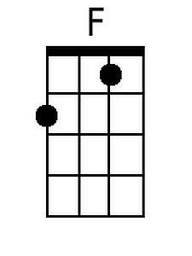
 |  |  |  |  |  |  |  |  | 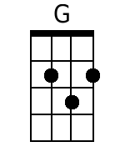
Bari
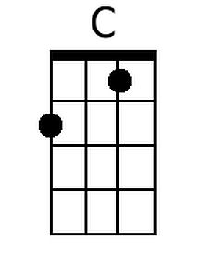 | 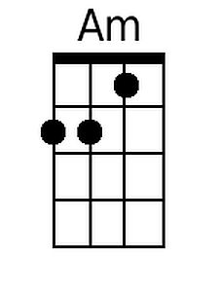 | 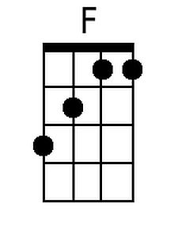 | 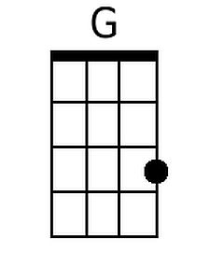

Hold Me Now (Alannah Joy Currie, Joseph Martin Leeway & Tom Bailey) (G)

Intro: G Em C D

G Em
I have a picture, pinned to my wall.
C D
An image of you and of me and we're laughing and loving it all.
G Em
Look at our life now, tattered and torn.
C
We fuss and we fight and delight in the tears
D
that we cry until dawn Oh-oh, oh-oh

Chorus
G Em
Hold me now, Woah-oh, warm my heart
C D
Stay with me, let loving start (let loving start) ______

G Em
You say I'm a dreamer, we're two of a kind
C D
Both of us searching for some perfect world we know we'll never find
G Em
So per-haps I should leave here, yeah yeah, go far away
C
But you know that there's nowhere that I'd rather be
D
than with you here today Oh-oh, oh-oh. Chorus (2x)

G Em
You ask if I love you, well what can I say?
C D
You know that I do and if this is just one of those games that we play
G Em
So I'll sing you a new song, please don't cry anymore
C
And then I'll ask your forgiveness,
D
though I don't know just what I'm asking it for.
Oh-oh, oh-oh. Chorus (3x) (End on G)

 |  |  |  |  |  |  |  |  | 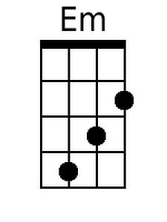
 |  |  |  |  |  |  |  |  | 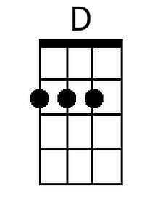
Bari
 | 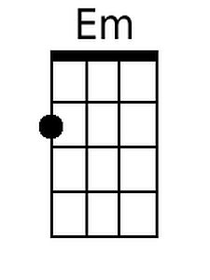 |  | 