Hooked On A Feeling (Mark James) (Blue Swede version) Key C




Intro: Ooogachaka ooga ooga (4x)
C
C7

C C7 F
I can't stop this feeling deep inside of me
C G7
But girl you just don't realize what you do to me
BARITONE
C C7


When you hold me in your arms so tight
G7
Am
Am C7
You let me know every thing's alright

Chorus:

F G7 C
Ah, I'm hooked on a feeling
C7 F
High on believing
G7 C G7
That you're in love with m—e

C C7 F
Your lips are sweet as candy the taste stays on my mind
C G7
Girl you keep me thirsty for another cup of wine
C C7 F
I got it bad for you girl but I don't need a cure
C G7
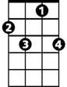

I'll just stay a victim if I can for sure
C7
F
CF

C C7
All the good love when we're all alone
Am C7
Keep it up girl, yeah, you turn me on


(Chorus)
G7
Am

C G7 C7 F G7

C C7
All the good love when we're all alone
Am C7
Keep it up girl, yeah, you turn me on

(Chorus) 2x

Hooked On A Feeling (Mark James) (Blue Swede version) Key G

Intro: Ooogachaka ooga ooga (4x)

G7
G
C
G G7 C
I can't stop this feeling deep inside of me
G D7
But girl you just don't realize what you do to me
G G7
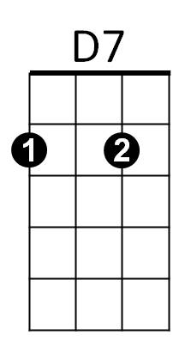
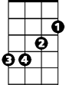
When you hold me in your arms so tight
Em
Em G7
You let me know every thing's alright

Chorus:

C D7 G
Ah, I'm hooked on a feeling
G7 C
High on believing
D7 G D7
That you're in love with m—e

G G7 C
Your lips are sweet as candy the taste stays on my mind
G D7
Girl you keep me thirsty for another cup of wine
G G7 C
I got it bad for you girl but I don't need a cure
BARITONE
G D7
G7
G
C
D7
Em
I'll just stay a victim if I can for sure

G G7
All the good love when we're all alone
Em G7
Keep it up girl, yeah, you turn me on

(Chorus)

G D7 G7 C D7

G G7
All the good love when we're all alone
Em G7
Keep it up girl, yeah, you turn me on

(Chorus) 2x

