Hotel California (Don Felder / Glenn Frey)
BARITONE


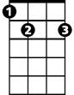
Intro: Verse melody
Am
E7
Am E7
On a dark desert highway, cool wi nd in my hair
G D7
Warm smell of colitas rising up through the air
F C
Up ahead in the distance, I saw a shimmering light
Dm E7
My head grew heavy and my sight grew dim; I had to stop for the night.

Am E7
There she stood in the doorway; I heard the mission bell
G D7
And I was thinking to myself, “This could be Heaven or this could be Hell”
F C
Then she lit up a candle and she showed me the way
Dm E7

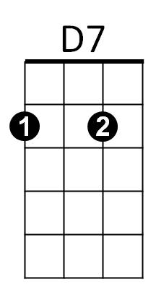
There were voices down the corridor, I thought I heard them say...
G

F C
Welcome to the Hotel California...
E7 Am G C
Such a lovely place, such a lovely face...
F C
Plenty of room at the Hotel California...

Dm E7
F
Any time of year, you can find it here...

Am E7
Her mind is Tiffany-twisted, she got the Mercedes Bends
G D7
She got a lot of pretty, pretty boys, that she calls friends


F C
C
Dm
How they dance in the courtyard, sweet summer sweat
Dm E7
Some dance to remember, some dance to forget

Am E7
Am
So I called up the Captain, "Please bring me my wine"
G D7
He said, "We haven't had that spirit here since nineteen sixty nine"
F C
And still those voices are calling from far away,
Dm E7
Wake you up in the middle of the night just to hear them say...

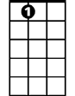
D7
E7
G
F C
Welcome to the Hotel California...
E7 Am G C
Such a lovely place, such a lovely face...
F C
They’re livin' it up at the Hotel California...

Dm E7
F
What a nice surprise, bring your alibis...

Am E7
Mirrors on the ceiling, the pink champagne on ice
G D7
And she said "We are all just prisoners here, of our own device"
F C
C
And in the master's chambers, they gathered for the feast
Dm E7
They stab it with their steely knives, but they just can't kill the beast

Am E7
Last thing I remember, I was running for the door

G D7
Dm
I had to find the passage back to place I was before
F C
"Relax" said the night man, "We are programmed to receive.
Dm E7
You can check out any time you like, but you can never leave".
Repeat verse melody to fade

