House at Pooh Corner (Kenny Loggins) (C)

Intro | Am F C Dm | Dm Gsus |  C Dm Em Am  Christopher Robin and I walked a-long,  Dm G7sus | C C G F |  Under branches lit up by the moon  C Dm Em Am  Posing our questions to Owl and Ee-yore,  Dm G7sus C  As our days disappeared all too soon  Am Em  But I've wandered much further to-day than I should  Fmaj7 D7 G  And I can't seem to find my way back to the wood  Chorus  C Em Dm G7sus  So, help me if you can, I've got to get  C Em Dm G7sus G7  Back to the house at Pooh Corner by one  C Em  You'd be sur-prised, there's so  Dm G G7  much to be done  Em C  Count all the bees in the hive,  Em Am  Chase all the clouds from the sky (To Coda 2nd Time)  F Em Am  Back to the days of Christopher Robin  Bbmaj7 G7  and Pooh.  C Dm Em Am  Winnie the Pooh doesn't know what to do,  Dm G7sus | C C G F |  Got a honey jar stuck on his nose  C Dm Em Am  He came to me asking help and ad-vice,  Dm G7sus C  And from here no one knows where he goes  Am Em  So, I sent him to ask of the Owl if he's there  Fmaj7 D7 G  How to loosen a jar from the nose of a bear. Chorus |  |  |  |  | Coda  F Em Am Bbmaj7  Back to the days of Christopher Robin and Pooh  G7sus C Dm Em Am7  La la la la la la la la la,  Dm G7sus | C C G F |  la la la la la la  | C Dm | Em Am | F G7sus | C C G F |  Chorus  C Em Dm G7sus  So, help me if you can, I've got to get  C Em Dm G7sus G7  Back to the house at Pooh Corner by one  C Em  You'd be sur-prised, there's so  Dm G G7  much to be done.  Em C  Count all the bees in the hive,  Em Am  Chase all the clouds from the sky  F Em Am  Back to the days of Christopher Robin  F Em Am  Back to the ways of Christopher Robin  F G Am | F G | Am |  Back to the ways of Pooh.  | F G | Am F C Dm | G C |  Oo _ _ _ _ _ _ _  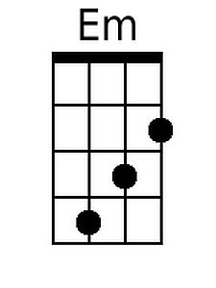  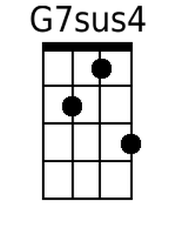  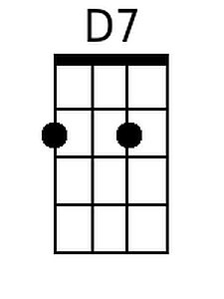 |  |  |  |  | 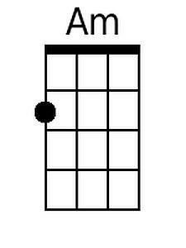
 |  |  |  |  |  |  |  |  |  | 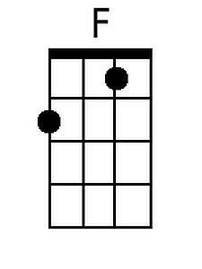
 |  |  |  |  |  |  |  |  |  | 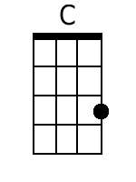
 |  |  |  |  |  |  |  |  |  | 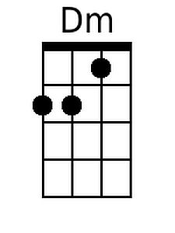
 |  |  |  |  |  |  |  |  |  | 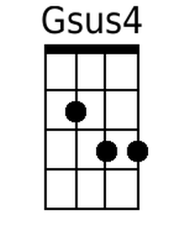
 |  |  |  |  |  |  |  |  |  | 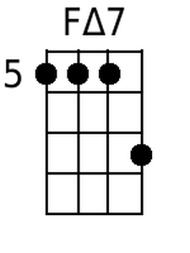
 |  |  |  |  |  |  |  |  |  | 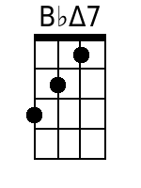
Bari
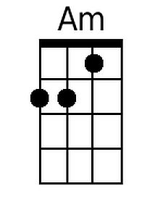 | 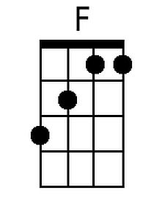 | 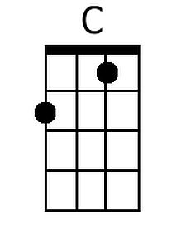 | 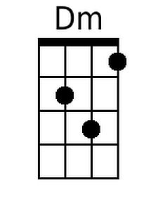 | 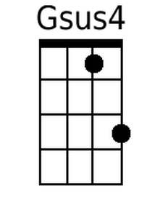 |  | 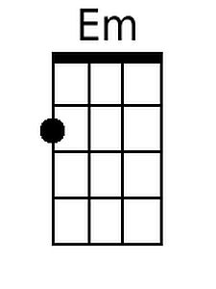 | 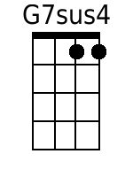 | 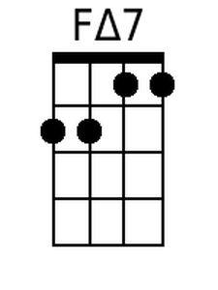 | 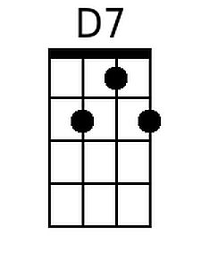 |  | 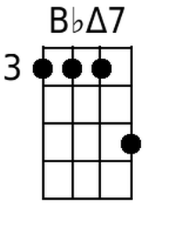

House at Pooh Corner (Kenny Loggins) (G)

Intro | Em C G Am | Am Dsus |  G Am Bm Em  Christopher Robin and I walked a-long,  Am D7sus | G G D C |  Under branches lit up by the moon  G Am Bm Em  Posing our questions to Owl and Ee-yore,  Am D7sus G  As our days disappeared all too soon  Em Bm  But I've wandered much further to-day than I should  Cmaj7 A7 D  And I can't seem to find my way back to the wood  G Bm Am D7sus  So, help me if you can, I've got to get  G Bm Am D7sus D7  Back to the house at Pooh Corner by one  G Bm Am D D7  You'd be sur-prised, there's so much to be done  Bm G  Count all the bees in the hive,  Bm Em  Chase all the clouds from the sky  C Bm Em Fmaj7 D7  Back to the days of Christopher Robin and Pooh.  G Am Bm Em  Winnie the Pooh doesn't know what to do,  Am D7sus | G G D C |  Got a honey jar stuck on his nose  G Am Bm Em  He came to me asking help and ad-vice,  Am D7sus G  And from here no one knows where he goes  Em Bm  So, I sent him to ask of the Owl if he's there  Cmaj7 A7 D  How to loosen a jar from the nose of a bear. |  |  |  |  | G Bm Am D7sus  So, help me if you can, I've got to get  G Bm Am D7sus D7  Back to the house at Pooh Corner by one  G Bm Am D D7  You'd be sur-prised, there's so much to be done  Bm G  Count all the bees in the hive,  Bm Em  Chase all the clouds from the sky  C Bm Em Fmaj7  Back to the days of Christopher Robin and Pooh  D7sus G Am Bm Em7  La la la la la la la la la,  Am D7sus | G G D C |  la la la la la la  | G Am | Bm Em | C D7sus | G G D C |  G Bm Am D7sus  So, help me if you can, I've got to get  G Bm Am D7sus D7  Back to the house at Pooh Corner by one  G Bm Am D D7  You'd be sur-prised, there's so much to be done  Bm G  Count all the bees in the hive,  Bm Em  Chase all the clouds from the sky  C Bm Em  Back to the days of Christopher Robin  C Bm Em  Back to the ways of Christopher Robin  C D Em | C D | Em |  Back to the ways of Pooh.  | C D | Em C G Am | D G |  Oo _ _ _ _ _ _ _
Bari

