Hula Heaven (Ralph Rainger / Leo Robin 1937 / Teresa Bright)
Intro: C F C A7 / D7 G7 C G7

C F C A7
We could be together
D7
In a little hula heaven
G7 C G7
Having dreams of love

C F C A7
So gay and free together
D7
In a little hula heaven
G7 C C7
Under a koa tree

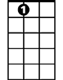
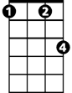

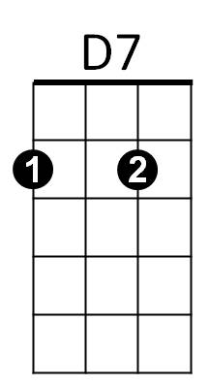
Chorus:
A7
Fm
C
F Fm
Days would be lazy
C A7
And sweetly crazy
D7 G7

Skies would grow hazy above
G7

C F C A7
And we'd be all alone t ogether
D7
In a little hula heaven
G7 C C7
Over a silvery sea

(Chorus)

(Repeat through Chorus)


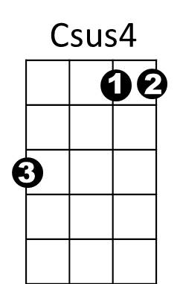
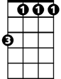

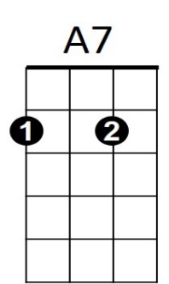

C
Fm
G7
D7
F
BARITONE

C F C A7
And we'd be all alone together
D7
In a little hula heaven
G7 C A7
Over a silvery sea
D7
In a little hula heaven
D#7
In a little hula heaven
D7
In a little hula heaven
G7 C Csus4 C
Having dreams of love
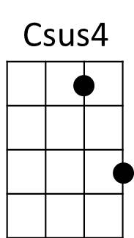
F

