Fun, Fun, Fun (Michael Love / Brian Wilson) Key C
Intro: C / F C G F G

C
Well she got her daddy's car and she's cruisin'
F
through the hamburger stand now
C
Seems she forgot all about the library
G G7
Like she told her old man now
C
And with the radio blasting
C7 F
Goes cruising just as fast as she can now

Chorus
C G
And she'll have fun fun fun
F G C
'Til her daddy takes the T-Bird away
F C G
(Fun fun fun 'til her daddy takes the T-Bird away)

C
Well the girls can't stand her
F
'Cause she walks looks and drives like an a ce now
(You walk like an ace now you walk like an ace)
C
She makes the Indy 500 look like
G
a Roman chariot race now
D7 G7
(You look like an ace now you look like an ace)
C
A lotta guys try to catch her
F
But she leads them on a wild goose chase now

(You drive like an ace now you drive like an ace)
C

(Chorus)

Intrumental/Solo G / C / G / D7 G7

BARITONE


G
F
C

C
Well you knew all along
F
That your dad was gettin' wise to you now
(You shouldn't have lied now you shouldn't have lied)
C
And since he took your set of keys
G
You've been thinking that your fun is all through now
D7 G7
(You shouldn't have lied now you shouldn't have lied)
C
But you can come along with me
F
'Cause we gotta a lot of things to do now
(You shouldn't have lied now you shouldn't have lied)

C G
And we'll have fun fun fun
F G C
Now that daddy took the T-Bird away
F C G C
(Fun fun fun now that daddy took the T-Bird away)
G
And we'll have fun fun fun
F G C
Now that daddy took the T-Bird away
F C G
(Fun fun fun now that daddy took the T-Bird away)

Outro (repeat and fade)

G C
(fun fun now that daddy took the T-Bird away)
F C G
(fun fun now that daddy took the T-Bird away)

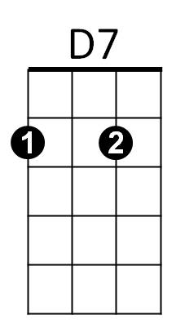

F
G
G7


G7
D7

Fun, Fun, Fun (Michael Love / Brian Wilson) Key G
Intro: G / C G D C D

G
Well she got her daddy's car and she's cruisin'
C
through the hamburger stand now
G
Seems she forgot all about the library
D D7
Like she told her old man now
G
And with the radio blasting
G7 C
Goes cruising just as fast as she can now

Chorus
G D
And she'll have fun fun fun
C D G
'Til her daddy takes the T-Bird away
C G D
(Fun fun fun 'til her daddy takes the T-Bird away)

G
Well the girls can't stand her
C
'Cause she walks looks and drives like an ace now
(You walk like an ace now you walk like an ace)
G
She makes the Indy 500 look like
D
a Roman chariot race now
A7 D7
(You look like an ace now you look like an ace)
G
A lotta guys try to catch her
C
But she leads them on a wild goose chase now
(You drive like an ace now you drive like an ace)
G

(Chorus)

Intrumental/Solo D / G / D / A7 D7

D
C
G

G
Well you knew all along
C
That your dad was gettin' wise to you now
(You shouldn't have lied now you shouldn't have lied)
G
And since he took your set of keys
D
You've been thinking that your fun is all through now
A7 D7
(You shouldn't have lied now you shouldn't have lied)
G
But you can come along with me
C
'Cause we gotta a lot of things to do now
(You shouldn't have lied now you shouldn't have lied)

G D
And we'll have fun fun fun
C D G
Now that daddy took the T-Bird away
C G D G
(Fun fun fun now that daddy took the T-Bird away)
D
And we'll have fun fun fun
C D G
Now that daddy took the T-Bird away
C G D
(Fun fun fun now that daddy took the T-Bird away)

Outro (repeat and fade)

D G
(fun fun now that daddy took the T-Bird away)
C G D
(fun fun now that daddy took the T-Bird away)

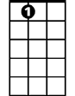
C
D
A7
BARITONE

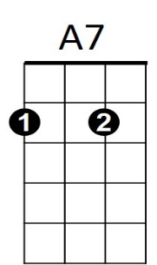
D7

