I Am Hawaiʻi (Mack David / Elmer Bernstein)

C F G7 Am






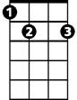
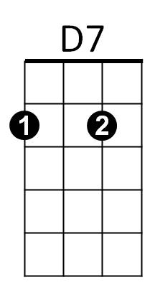
I am Hawaiʻi, I am forever
C
F
G7
G
Am
Dm
E7
F G Am D7 E7
I will always be kind to you
Dm F Em7
May gentle rain wash your cares far out to sea
Em Am D7 E7 G7
Come you dreamers and dream with me

C F G7 Am
I am Hawaiʻi, I am the flowers
F G Am D 7 G7
Whispering waters, enchanted hours
F G7 C Am
Come you lovers, come to forever
C F G7 C
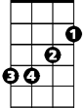
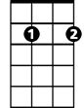
I am Hawaiʻi, I'll bring you love
Em
Em7

(Play G7 to repeat song, slow last line end C)



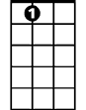
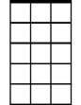
BARITONE
C
F
G
G7
Am
D7
Dm
E7
Em
Em7

